Please note – this learning resource has been produced by the GUMS Academic Team. It is possible that there are some minor errors in the questions/answers, and other possible answers that are not included below. Make sure to check with other resources.
Case 1
14 year old Lamotri Jean is referred to you by his local GP after experiencing 3 seizures within the last month. His symptoms included aponea, tongue biting, dilated and unresponsive pupils followed by rhythmic muscle contractions.
- What is the definition of epilepsy according to ILAE classification
- Is a disorder characterised by the tendency to experience recurrent seizures
  - At least two unprovoked (or reflex) seizures occurring more than 24 hours apart
  - One unprovoked (or reflex) seizure and a probability of further seizures similar to the general recurrence risk (at least 60%) after two unprovoked seizures, occurring over the next 10 years
  - diagnosis of an epilepsy syndrome
- Epilepsy can be the primary problem or a symptom of another brain disorder
- About half the patients who have a seizure for the first time do not have another, and do not have epilepsy.
- What are the 3 factors used when classifying a seizure?
- Where in the brain the seizure starts (e.g. the onset) - focal vs generalised
  - Focal seizures
    - start in one cerebral hemisphere
    - more likely to be caused by focal structural abnormalities
    - Symptoms depend on the anatomical location of the lesion or disturbance within the brain
    - Can evolve to be generalised seizures
  - Generalised seizures
    - usually start in both hemispheres simultaneously - bilateral cerebral cortex disturbance
- If the person is aware or not during the seizure - preserved or impaired awareness
  - Mostly used for focal seizures since awareness is almost always affected in some way in generalised seizures
- Whether the seizure involves movement - motor vs non-motor
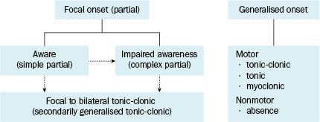
  - motor seizure
    - may involve stiffening (tonic) and jerking (clonic) or other movements
  - non-motor seizure
    - These seizures involve brief changes in awareness, staring, and some may have automatic or repeated movements like lip-smacking.
Flow chart from Australian Therapeutic Guidelines (eTG) Epilepsy classification
(dotted lines represent that it can start as one type and evolve to another type)
- List the different types of seizures
- Always changing but it is based on the International League Against Epilepsy (ILAE) classification
- Focal seizures
  - focal seizures without dyscognitive features (simple partial) – consciousness is not impaired
  - focal with dyscognitive features – (complex partial) – impaired consciousness
  - focal seizures evolving to secondarily generalised seizures
- Generalised seizures
  - Tonic-clonic seizures (grand mal) - most common type of seizure
  - Absence seizures (petit mal) - most common type of of generalised epilepsy in childhood)
  - Myoclonic seizures
  - Clonic seizures
  - Tonic seizures
  - Atonic seizures (drop attacks)

- Why is it important to correctly classify the type of epilepsy a patient has?
- the best chance of achieving seizure remission depends on using the right medication for the right seizure type
- Anti-Epileptic Drugs (AEDs) are definitely not interchangeable, and vary enormously in efficacy for different seizure syndromes
- Choosing the wrong AED can WORSEN some seizure syndromes, particularly narrow spectrum agents and in Juvenile Myoclonic Epilepsy

- Describe the different phases in seizures
- Usually no prodrome; occurs suddenly
- Ictal phase - (The period of abnormal electrical brain activity when a seizure is occurring)
  - Sudden onset
  - Rapid progression of symptoms
  - Duration usually 1-3 minutes
    - the majority resolve spontaneously.
    - Prolonged seizures may be indicative of acute underlying cause or status epilepticus.
- Postictal phase - (The phase immediately after the end of a seizure)
  - Can last minutes to hours
  - Varying degree of confusion, impaired alertness
  - Neurological symptoms (e.g. Todd’s Paralysis) (can mimic stroke)
    - Typically involves confusion, drowsiness, headache, speech impairment, and weakness.

- Fill in the following table with the typical symptoms for each type of seizure
**Answers provided are quite extensive and this is provided for completeness. Students should more so have a general idea of the difference between seizure types**
Type | Ictal symptoms | Postictal symptoms
Focal
Focal seizure WITHOUT dyscognitive features - Simple Partial | Prodromal symptoms: auras  Intact consciousness  Motor symptoms  Clonic, involuntary, repetitive movements of the contralateral limbs or facial muscles.  Jacksonian march (“march of convulsions”): progressive involvement of muscle groups  Sensory and psychiatric symptoms  Visual (e.g., hallucinations, micropsia, macropsia)  Somatic (e.g., paresthesias)  Position (e.g., vertigo)  Hearing (e.g., hearing complex sounds)  Olfactory (e.g., unusual or intense smells)  Autonomic symptoms (e.g. flushing, sweating) | Residual neurologic deficits depending on the affected cerebral region (can mimic a TIA)  Todd's paralysis
Focal seizure WITH dyscognitive features - Complex Partial  Often occur in the temporal lobe (70-80%)  Subsequent bilateral spread | Auras: sensory and psychic symptoms (e.g., deja vu, disorientation, fear, vertigo, and visual, acoustic, olfactory, or gustatory hallucinations)  Sudden behavioral arrest (e.g., staring without moving)  Impaired consciousness  Automatisms (e.g., fumbling, lip smacking, chewing, swallowing) | Confusion  Anterograde amnesia  Aphasia  Fatigue, possibly short phase of coma  Muscular flaccidity and muscle pain  Headache
Generalised
Tonic-clonic  seizures (grand mal)  **go over symptoms more thoroughly since most common type of seizure** | Prodromal symptoms may occur hours before seizure onset (e.g., sleep disturbances, lightheadedness, mood changes, anxiety/irritability, impaired concentration)  Loss of consciousness (sudden, often without any warning)  Motor symptoms:  Tonic phase:  Generalized muscle contractions: rotated eyes, aponea, lateral tongue biting, pooled oral secretions, cyanosis and uttering of an “ictal cry”  Increased sympathetic tone: dilated, unresponsive pupils, ↑ HR and ↑ blood pressure  Clonic phase - rhythmic muscle twitching  Bladder or bowel incontinence  Tongue bite lacerations | Unresponsiveness  Confusion  Amnesia  Aphasia  Fatigue  Muscular flaccidity and muscle pain  Headache  Hypersalivation with or without airway obstruction
Clonic seizures | Loss of consciousness  Rhythmic jerking motor movements (of the entire body or only a part) | None
Tonic | Loss of consciousness (often occur when the patient is drowsy, asleep, or after waking)  Muscle contractions (extension or flexion of the head, trunk, and/or extremities). Go stiff, can fall backwards | None
Myoclonic seizure | Brief loss of consciousness  sudden jerky muscle twitching (of the entire body or only a part) | None
Atonic seizure “drop attacks” | Brief loss of consciousness  Sudden loss of muscle tone: sudden head drop or collapse (lasts ∼ 2 seconds). Can fall forwards | None
Absence seizure (petit mal) | Brief loss of consciousness  Interrupted motion or activity, blank stare, unresponsiveness  Can occur several hundred times a day and usually ceases after 5–20 seconds  Very subtle automatisms (often go unnoticed!): lip smacking, eye fluttering, or head nodding are common | None  Consciousness returns rapidly without any impairment  Patient is usually unaware of interruption
Table adapted from Amboss - Seizure Disorders

- What type of epilepsy is Lamotri most likely suffering from
- Most likely is suffering from generalised tonic clonic seizures
- However, further investigations would be need to be performed to confirm diagnosis

- How would a diagnosis be made of epilepsy in Lamotri
- Primarily a Clinical diagnosis
  - Relies primarily on a description of the seizures
  - eyewitness account or video can help exclude other causes of loss of consciousness (e.g. syncope)
  - Prior events
- EEG
  - Can support a the diagnosis but a normal EEG does not exclude a diagnosis of epilepsy nor does a abnormal EEG necessarily confirm the diagnosis
  - Routine EEG may be of limited use due to difficulty in capturing a seizure in a short period of time
  - 24 hour or longer EEG monitoring is frequently more useful and may confirm diagnosis - can be done as an outpatient or as a inpatient with video monitoring
- Brain imaging
  - MRI especially can often be useful in revealing the cause but cannot confirm the diagnosis
- Lab tests
  - Glucose, electrolytes, toxicology screen

You decide that Lamotri should be put on an anti-epileptic and put him on Sodium Valproate (Epilim) 200mg twice a day.

- What are some general considerations you need to take into account before starting Lamotri on a Anti-Epileptic Drug?
General steps of epilepsy treatment
- Start treatment with 1 drug only as more does not always equal better - increased side effects/behavioural issues
- Start low and go slow and same for if stopping treatment always taper slowly
- Treat the cause NOT the symptom
- Be clear whether the symptoms being treated are
  - Inctal
  - Post ictal
  - Interictal - part of the other 99% of the patients life
  - Non-epileptic
- All epilepsy is not the same , All seizures are not the same, All people are not the same
  - Treat the person not the disease
  - Go for quality of life not just symptom control (take into account how AEDs side effects may impact a person life)
  - Individuals respond to AEDs differently
  - Special patient populations - pregnancy, children, elderly

General information on AEDS
- AEDs can be classified in multiple ways
  - Historically classified as old vs new generation -
    - neither is more effective when used at the right dose for the right indication however side effects and interactions are more common in older generation
  - Can classify according to target/mechanism of action -
    - However this can be a bit difficult with AEDs that have multiple targets
  - More useful classification is narrow-spectrum vs broad-spectrum -
    - Narrow spectrum only effective for focal epilepsy but often very effective
    - Broad spectrum effect both focal and generalised epilepsies

- Complete the following table on common Antiepileptic drugs stating the brief mechanism of action and indication

Agent | Mechanism of action | Indications
Sodium Valproate  (Epilim) | Inhibits GABA transaminase > increase in GABA > decreased neuronal excitability  Inactivates sodium channels - preventing repetitive neuronal discharge  Blocks T-type calcium channels | First line for tonic-clonic generalized seizures and absence and myoclonic seizures  Can also be used in atonic seizures and focal (partial) seizures and bipolar disorder
Carbamazepine  (Tegretol) | Inactivates sodium channels | First line in focal (partial) seizures  And can be first line for tonic-clonic generalised seizures  Trigeminal and glossopharyngeal neuralgias
Ethosuximide  (Zarontin) | Inhibition of T-type (voltage gated) calcium channels in thalamic neurons | First line for absence seizures
Phenytoin  (Dilantin) | Inactivation of sodium channels, may also affect Calcium and chloride channel activity | First line in status epilepticus prophylaxis  Can be used in tonic-clonic seizures and focal (partial) seizures
Benzodiazepines  - Diazepam  - Clobazam  - Midazolam  - Clonazepam | Indirect GABA_{A} agonist > increased GABA action | First line for treatment of status epilepticus and acute treatment of seizures
Lamotrigine  (Lamictal) | Stabilises presynaptic neuronal membranes by blocking voltage-dependent sodium channels and inhibiting glutamate release. | First line for long term treatment of focal seizures  Second line for generalised seizures and absence seizures  Can be used as a mood stabiliser for bipolar treatment (depressive episodes)
Phenobarbital  (Phenobarbitone) | Barbiturate - GABA_{A} agonist > increased GABA action | First line treatment in neonates  Tonic Clonic seizures  Focal seizures
Levetiracetam  (Keppra) | Mechanism unknown - may modulate neurotransmission by binding to synaptic vesicle protein 2A | First line treatment for long term treatment of focal seizures  Also used in generalised seizures
Topiramate  (Topamax) | Blocks voltage gated sodium channels  Increases GABA | Focal and generalised tonic clonic seizures  Migraine prophylaxis

- What are the side effects of Sodium Valproate?
- GI upset - nausea, vomiting, diarrhoea and anorexia
- Drowsiness
- Tremor
- Weight gain
- Hair loss
- Hepatotoxicity (rare)
- Teratogenicity
  - Risk of neural tube defects, autism and developmental delay
  - avoid in women of child bearing age - use as last resort and if used then ensure adequate contraception and supplement with folate

Lamotri is brought into the ER department 10 weeks later after suffering from multiple seizures in the past hour without gaining consciousness in between. You are the ER intern and you take a history from Mrs Jean, his mum, who reveals that Lamotri stopped taking his sodium valproate 2 days ago due to gaining weight from the medication, without consulting his specialist (stopped abruptly).

- a) What has happened to Lamotri
- Suffered from Status epilepticus due to abrupt AED withdrawal
- Serious and often life threatening medical condition
- The most common medical neurological emergency
- Can result in neuronal injury/death, alteration of neuronal networks depending on the type and duration of seizures

b) What is the definition of this condition and what are some common causes?
- A continuous seizure that lasts ≥ than 5 minutes
- OR ≥ 2 seizures where consciousness is not fully regained in the interictal period
- Causes - anything that lowers ‘seizure threshold’
  - Withdrawal from antiepileptic drugs - taper down slowly
  - Metabolic disturbances (e.g. hyponatremia)
  - Drug toxicity (tricyclic antidepressants)
  - Structural brain lesions/injury (e.g. tumors, trauma, stroke)
  - CNS infections

As you are examining Lamotri in the ER, he suffers from another seizure that still hasn't stopped 5 minutes later.

- What is the treatment for status epilepticus
- Beware protocols for treatment vary between adults, children and neonate - below is representative:
  - Provide basic life support
    - Oxygen
    - Maintain BP and blood glucose concentration
  - First line - fast acting benzodiazepine to control seizures
    - Midazolam 5-10mg IM, IV, intranasal or buccal
    - OR clonazepam (IV)
  - If seizures continue and/or to prevent recurrence give a long acting antiepileptic drug
    - IV phenytoin, valproate, phenobarbital or levetiracetam
  - If status epilepticus persists give anaesthetic doses of thiopental, midazolam or propofol
    - assisted ventilation is usually required because of the risk of severe respiratory depression

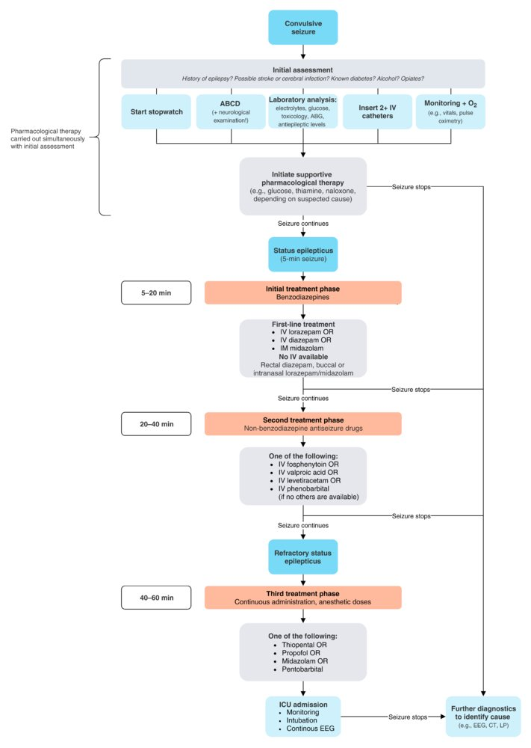
Flow chart from Amboss - seizure disorders
WHAT IFs
- What if Lamotri was a 24 year old female instead, how would this her affect treatment
- Do NOT give valproate unless last resort due teratogenicity
  - If have to give to child bearing age give adequate contraception
  - If patient fall pregnant on valproate the need to change to an alternative agent quickly - absolutely contraindicated
  - A pregnancy test is essential proir to commencing even if using in status epilepticus
- Educating the patient is really important!!
  - Do pregnancy counselling BEFORE they are even thinking about conceiving
  - Informed consent - make sure they are aware of the teratogenic effects of some AEDs vs adverse effects of Seizures on the fetus
- Make sure they are taking Folate 5 mg daily (especially with Valproate) BEFORE even thinking about pregnancy
- Do NOT stop all AEDs when they become pregnant: risk of seizures to fetus is high but Try to wean down to monotherapy of the least teratogenic AED for their epilepsy syndrome
- Many pharmacokinetic and dynamic changes of AEDs in pregnancy: need to monitor levels
- Often need to monitor free levels of AEDs as protein binding changes
- Beware that many AEDs reduce the efficacy of hormonal contraception by inducing hepatic enzymes
  - Particularly carbamazepine, oxcarbazepine, phenobarbitone, phenytoin, topiramate
  - Effective contraception is provided by depot medroxyprogesterone, intrauterine devices such as mirena (hormonal) or copper IUD
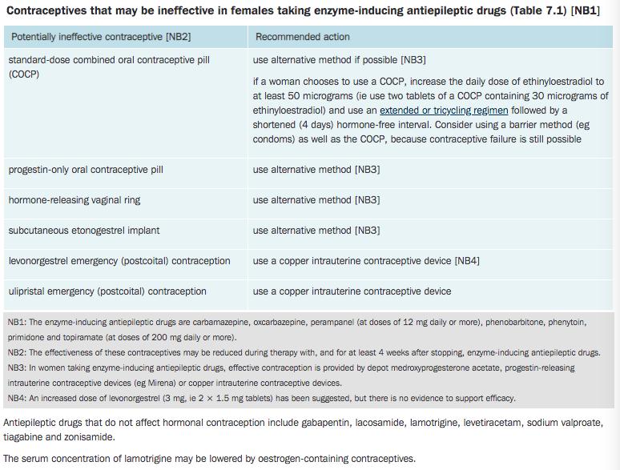

Table from the Australian Therapeutic Guidelines ( eTG) Epilepsy and seizures “Contraception in patients with epilepsy “
What if Lamotri experiences an overwhelming sense of fear, is sweating and has a rapid heart beat around the time of his seizure?
- What could Lamotri be suffering from?
- He could be experiencing Ictal Psychiatric symptoms
- Seizures manifest differently in every person and so if the seizure focus is closely connected to the limbic system than a huge range of psychiatric presentations are possible as seizure manifestations

- List some psychiatric Ictal Symptoms that people with epilepsy can present with?
- Depressive symptoms
- Psychosis -
  - hallucinations (auditory/visual) - may resemble a schizophrenia like state
  - Feelings of “unreality”, “deja-vu”
  - Delusions
  - Or other psychic sensations
- Anxiety, panic attacks
- Confusion

- Why is it important to to differentiate if the psychiatric symptom is an ictal or postictal symptom or if it is unrelated to the epilepsy
- The treatment depends on the cause -
  - The cause may relate to the persons epilepsy, to the seizures, to an underlying syndrome that includes seizures and mental health morbidity, to the antiepileptic drugs or it may be unrelated
- It is critical to diagnose behavioural disturbance that is directly related to seizures i.e. ictal as the treatment differs greatly from psychiatric presentations from other causes
- The important thing is to diagnose and treat the seizures in these instances and not use psychotropic drugs which may exacerbate the symptoms

Please provide feedback for this case at: https://gums2020.typeform.com/to/e0h7US

References
- Amboss
- AMH
- eTG
- Up-to-date

