Please note – this learning resource has been produced by the GUMS Academic Team. It is possible that there are some minor errors in the questions/answers, and other possible answers that are not included below. Make sure to check with other resources.

Meredith Grey is a 30 year old woman you have met whilst on placement with a general practitioner in Noosa. She has come to the GP today looking for advice as her and her partner, Derek Shepherd, feel like they are now ready to start a family.

- Describe the hormonal fluctuations that occur throughout the menstrual cycle and when Meredith would be most likely to fall pregnant. (Think about LH, FSH, Oestrogen and Progesterone)
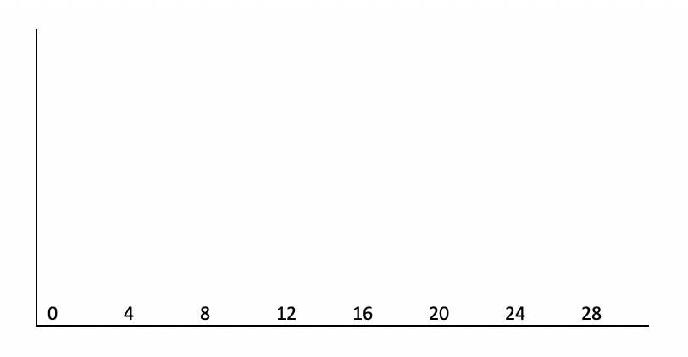

- You have an excellent relationship with both your supervising GP and Meredith. You are asked to conduct a menstrual and sexual history for Meredith prior to her appointment.
List below important questions to ask your patient.

- Three months later, Meredith comes back to the GP clinic very upset. She thinks she is pregnant, however she has been unfaithful to her husband Derek, and does not know if the baby is his. She has not menstruated for well over one month and today is 9 days since her expected first day of menses. She usually ovulates on day 15 of a 30 day cycle. Exactly 4 weeks ago (28 days) she began having sexual intercourse four times over 2 days with another man Finn Dandridge. She abstained for two days and then had sexual intercourse twice over 24 hours with Derek. Then she abstained again for one week, before having sexual intercourse with a third guy Nathan Riggs three times over 2 days. If Meredith is pregnant, who is the most likely father and explain why.

- Show on the graph the hormonal changes that occur throughout pregnancy and explain each of their roles. (Focus on Oestrogen, Progesterone and hCG)

0 | 4 | 8 | 12 | 16 | 20 | 24 | 28 | 32 | 36 | 40

- How are the above hormones used to confirm pregnancy?

- What is the ideal screening test in terms of sensitivity and specificity? How does this change for a diagnostic test?

- What is the organisation of the genetic material in a diploid and haploid cell?

- Explain the production of gametes (meiosis) and how genetic diversity is ensured. (focus on which cells are diploid and which are haploid)

- Fill in the table outlining the range of abnormal events that can occur in meiosis and their consequences. (focus on numerical and structural abnormalities)

Type of disoder | Example | Outcome
Numerical:

Numerical:

Structural:

Structural:

Structural:

Structural:

Structural:

Structural:

- Describe the different types of genetic inheritance patterns.

- What screening tests are used throughout pregnancy?

Meredith has a discussion with Derek about her pregnancy and voices her concerns over who the father of the child could possibly be. Meredith and Derek decide to go ahead with the pregnancy as a couple.

- If Meredith was to decide to terminate the pregnancy, would this be lawful in Queensland? Explain the relevant legislation.

Please provide feedback for this case at:
https://forms.gle/R64a83Cf7UgRYc168

