Please note – this learning resource has been produced by the GUMS Academic Team. It is possible that there are some minor errors in the questions/answers, and other possible answers that are not included below. Make sure to check with other resources.
What are the likely morphological classification of anaemia seen in the following cases (eg. Macrocytic, microcytic and normocytic) and discuss why

1) A 20 year old woman complaining of fatigue, lethargy and occasional shortness of breath, has just found out she is pregnant, eats a vegetarian diet and has suffered from heavy menstrual bleeding.
Microcytic anaemia
This is a case of Iron deficiency anaemia which is commonly a mixed picture with diet alone being seldom sufficient for an iron deficiency.
It is more common therefore, for iron deficiency anaemia to present with low iron diet and one of the following
blood loss (chronic) --- heavy menstrual, peptic ulcers etc
Malabsorption of iron (duodenum);
↑ iron requirement (rapid growth in infancy, childhood, pregnancy, lactation, cancer)
Essentially this will result in a microcytic anaemia (small MCV)
Microcytic anaemia occurs as there is a defective haemoglobin synthesis due to the lack of iron

2) A 6 year old boy of Mediterranean descent with Beta- Thalassaemia as diagnosed by haemoglobin electrophoresis.
Microcytic anaemia -> defective haemoglobin due to mutation in beta chain gene -> Structural issue with the beta chain of haemoglobin resulting in aggregation of alpha chains and changes in haemoglobins structure.
3 ) A 30 year old women diagnosed with Crohn’s disease (an inflammatory bowel disease that affects transmural gastrointestinal tract and impairs absorption) that is particularly affecting her terminal ileum (hint (this is covered in systems): Iron (fe = duodenum) fist ( folate = jejunum) buddy buddy (bile and B 12 = terminal ileum)
B 12 deficiency leads to MACROCYTIC anaemia
B12 combines with intrinsic factor to be absorbed in the terminal ileum, thus if Crohn’s disease was present at the terminal ileum, it could result in B12 malabsorption.
Due to lack of B12 this causes defective DNA synthesis – thus the RBCs are unable to fully mature and become large (macrocytic) and premature
Note: Iron deficiency anaemia or mixed is the most common type of anaemia that arises in crohns disease(IBD). This is due to intestinal bleeding, the malabsorption of B12 in this scenario is to highlight B12s absorption only.
- A 50 year old man brought in by ambulance to the ED with multiple abdominal stab wounds who is bleeding profusely.
Normocytic: No issues in haemoglobin synthesis or degradation etc (no pathophysiology) at the moment because most of the blood is on the floor.
NB: If you took a blood sample right at the time they were bleeding profusely, they might not even be anaemic.
- A 70 year old woman who is currently receiving dialysis for failing kidneys
Normocytic:
CKD - ↓erythropoietin = ↓ no. of RBC made however synthesis process is still normal (eg. Nil haem/ globin issues)

What does the P wave represent?
Atrial depolarisation

What does the T wave represent?
Ventricular Repolarisation

Lub dub:
S1 is heard due to
Beginning of Systole: so the ventricles are beginning to contract and rising pressure causes the mitral and tricuspid valves to close, the sound is turbulent blood flow caused by blood hitting the closed mitral and tricuspid valves.

S2 is heard due to
Beginning of diastole: the relaxation of the ventricles aortic and pulmonary valves closing, the sound is turbulent blood flow caused by blood hitting the closed aortic and pulmonary valves

Explain the difference between essential and secondary hypertension with examples.
Essential HTN (essential HTN) : no exact identifiable cause of HTN, however thought to be associated with lifestyle factors (age, diabetes, smoking, obesity, environment, family history)
Secondary HTN: identifiable cause e.g. renal artery stenosis (↓blood flow to kidney = ↑ renin) Pheochromocytoma (adrenaline producing tumour), Aortic coarctation (↓blood flow to kidneys ↑ renin) etc.

Explain the difference between primary and secondary hyperlipidaemia with examples
Primary hyperlipidaemia: due to family history/ genetic disposition (therefore is non-modifiable and requires medications needed to address lipid profile.
Secondary hyperlipaemia: Due to secondary causes (eg. Diabetes, lifestyle, see secondary HTN)

PART 2 ANSWERS
Question 1: What is the mechanism of action of nitrates (Nitroglycerin) in regards to the heart and coronary vessels?

Nitrates cause relaxation of smooth muscle cells within the tunica media of blood vessels causing vasodilation, specific to the heart, they increase coronary blood flow.

Question 2: During a normal cardiac cycle: what is the state of heart valves during diastole?

During diastole, the heart's muscles are relaxed and blood is entering its chambers. The AV (mitral and tricuspid) valves are open to allow blood flow from the atria into the ventricles. The semilunar (aortic and pulmonary) valves are closed to prevent backflow from the aorta and pulmonary trunk.

Mr Sanders presents to the ED clutching his chest and complaining of chest pain.

Question 3:
Name 6 medical conditions that could have cause Mr Sander’s chest pain (you may not have covered all 6):
Vascular (2): Aortic dissection, Pulmonary Embolism
Cardiac (2): Acute coronary syndrome (STEMI) = angina, Cardiac Tamponade
Respiratory (1): Pneumothrax, pleural effusion
GI (1): Heart burn (Gastro-reflux) Boerhaave's syndrome (oesophageal rupture)

Question 4:
What is the main clinical difference between Stable and Unstable Angina?
Stable Angina: Pain on exertion. Resolves with rest
Unstable Angina: Pain at rest

Mr Sanders has been overweight for most of his adult life, despite numerous attempts to lose weight. He began to smoke 5 years ago. He lives with his wife and 2 children. He has a history of hayfever, but is otherwise generally well.

Question 5:
Name 2 Modifiable and 2 Non-Modifiable Risk Factors Mr Sanders has for Angina

Modifiable: Diet and Smoking
Non Modifiable: Male and Age

Question 6
Place the following in the correct order of the formation and development of an atherosclerotic plaque (1-10)

LDLs (low density lipids) become oxidised and release chemotactic agents. | 3
Endothelial cells become activated and macrophages produce chemicals that activate smooth muscle cells and cause their proliferation and migration into the tunica intima blood vessels. | 7
A fibrous cap forms, containing ECM (extracellular matrix) proteins such as collagen and fibrin | 8
There is a loss of endothelial integrity and initiation of the inflammatory process | 1
LDLs move from the lumen of the blood vessels into its tunica media | 2
Macrophages engulf the oxidised LDLsm transforming into foam cells. | 6
Monocytes are attracted to the area | 4
The lipid core can become necrotic. | 10
The fibrous cap hardens and has the potential to rupture, this triggers the formation of a thrombus. | 9
Monocytes migrate between the tight junctions of the endothelial cells to reach the sub-endothelial space and differentiate into macrophages. | 5

Appendix to help

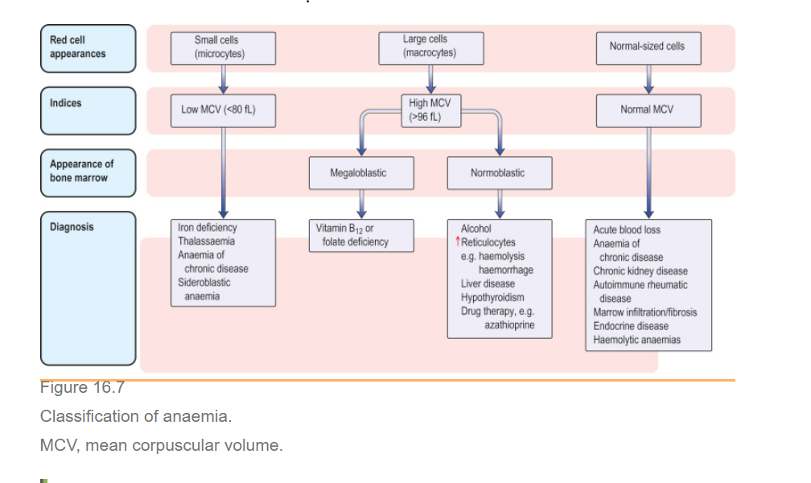
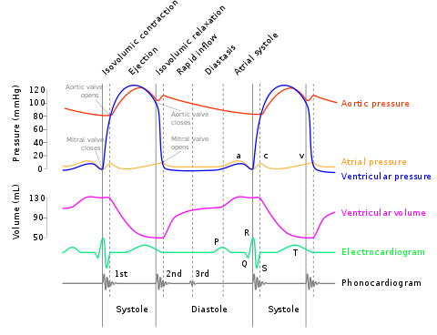
Please provide feedback for this case at: https://gums2020.typeform.com/to/e0h7US

