Please note – this learning resource has been produced by the GUMS Academic Team. It is possible that there are some minor errors in the questions/answers, and other possible answers that are not included below. Make sure to check with other resources.

- Jake Peralta walks into the ED with acute onset shortness of breath. Which of the following additional bits of information would make you MOST concerned about a pulmonary embolism (PE)?

- Takes 100mg aspirin daily
- Has atrial fibrillation
- Has a factor V leiden mutation
- Has had recent surgery
- Has an abnormal chest xray

A – aspirin is an anti-platelet medication
B – atrial fibrillation would increase the risk of stroke
C – factor V leiden is a genetic defect which makes factor V resistant to degradation by protein C and S therefore resulting in a hypercoaguable state. It increases the risk of a venous thromboembolism by about 1.5x.
D – having had recent surgery increases the risk of venous thromboembolism by 10x. The point here is that the clinical scenario (e.g. recent surgery, trauma, cancer) is more important than wacky genetic defects.
E – most commonly the CXRs of patients with PEs are found to be normal. There are some radiological signs of PE on CXR but the sensitivity and specificity are poor.

2. You’re taking a history in ED from a patient, Amy Santiago, who presents with unilateral calf pain of 1 day duration. Describe Virchow’s triad and then list how the following risk factors may affect the components of the triad.

- Being pregnant

- Having recently been on a long haul flight

- Taking an ACE inhibitor

- Taking the oral contraceptive pill

What is Virchow’s triad?
Virchow’s triad describe the major factor which contribute to thrombosis and clot formation
1. Hypercoagulable state – Cancer, pregnancy
2. Blood stasis – immobility, varicose veins, venous obstruction
3. Vessel damage – Surgery, inflammation

 | Effect on Virchow’s triad | Explanation of how the factor affect Virchow’s triad.
- Being pregnant | ↑ coagulability of blood  ↑ venous stasis | More clotting factors produced in pregnancy and more resistance to anticoagulant proteins. There is also more venous stasis caused by a gravid uterus compressing the veins.
- Having recently been on a long-haul flight | ↑ venous stasis | Sitting down for a long time compresses the veins in the legs, leading to venous stasis.
- Taking an ACE inhibitor | ↓ coagulability of blood | Prevent breakdown of bradykinin which enhances fibrinolysis.
- Taking the oral contraceptive pill | ↑ coagulability of blood | Oestrogen contained in the OCP creates a hypercoagulable state.

3. Platelets can do all of the following EXCEPT:

- Adhere to injured vascular walls
- Convert fibrinogen to fibrin
- Induce vasoconstriction
- Provide a surface for coagulation to take place
- Release substances that neutralize heparin

The conversion of fibrinogen 🡪 fibrin is done by factor II (thrombin) and is the end result of the coagulation cascade and not primary haemostasis (platelet adhesion)

4. On the same day as Jake and Amy, Charles Boyle, a detective, presented with sudden onset shortness of breath on day 2 after a total knee replacement. Your colleague (who went to an inferior medical school) decided to order a D-dimer test to investigate the possibility of a venous thromboembolism. Why is this a silly idea?

D-dimer is fibrin degradation product which correlates with activity of coagulation and fibrinolysis. It is a high sensitivity but low specificity kind of test. This means it is good at ruling out a PE in the kind of situation where the pre-test probability is already low (e.g. patient seeing their GP in the community). In anyone who’s just had an operation, d-dimer will be high (because of all the recent clotting and wound healing) and therefore this test gives no useful diagnostic information. D-dimer is often seen to be increased non-specifically in patients who are generally unwell (e.g. sepsis/infection, heart failure, malignancy).

5. Charles then decides to ask you about why he was getting a DVT in the first place? Strangely, Charles is very interested in the roman numerals of the clotting cascade. Describe in layman’s terms to Charles (non-science background), haemostasis and the key aspects of the clotting cascade.

When there is an injury to the blood vessel, a variety of changes occur at the site of injury and within the blood itself to prevent or limit bleeding.
This can be broken down into 4 main steps (students should know VERY generally what happens, doesn’t need to be exact)

1. Arteriolar vasoconstriction
- At the site of injury your vessels constrict (get smaller) to reduce the blood flow
- Done by reflexes and release of local factors (e.g. endothelin) in response to damage

2. Primary haemostasis
- This process involves your bodies platelets, which act like sticky glue to sticking both to the vessel walls and to each other to form a ‘platelet plug’ preventing blood from escaping.
- This is done through the damaged vessel exposing collagen and Von Willebrand factor (special endothelium factor) which promotes platelet adherence and activates them.
- Activated platelets then release further factors (ADP, collagen, TXA2, thrombin) to recruit more platelets to the plug

3. Secondary haemostasis
- This is otherwise known as the coagulation cascade and occurs on the surface of activated platelets
There are two key pathways, with various factors activating each other
Extrinsic
Tissue factor -> Factor VII -> X
- Tissue factor is exposed at the site of injury and thus can initiate the clotting cascade
Intrinsic
XII -> XI -> IX + VIII -> X
Common pathway
X + V -> II
Here the end result of the extrinsic and intrinsic pathway is to activate factor X, which in combination with factor V activates factor II (thrombin) to catalyse the formation of fibrinogen to fibrin, consolidating the initial platelet plug to a fibrin plug with factor XIII.

4. Clot breakdown
At the same time thrombin activates tissue plasminogen activator, which stimulates plasminogen -> plasmin, which in turn begins to break down the blood clot via the conversion of fibrinogen into breakdown products such as D-dimers.
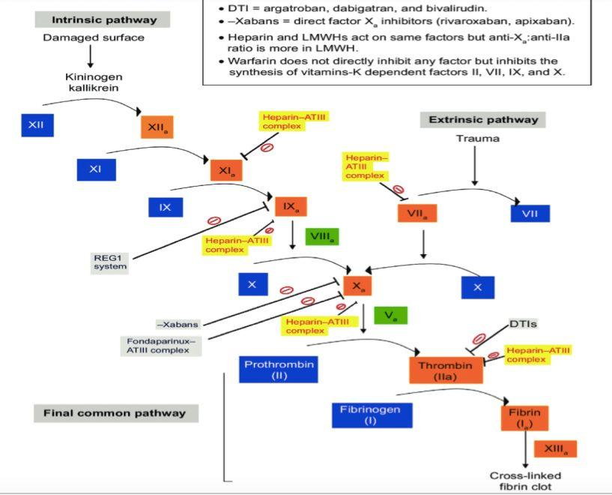

6. Yet another patient (it really is a busy day), Scully, presents to the ED. Scully is a 73 year old man who has recently had his first ischaemic cerebrovascular accident (stroke). Your colleague wants to start him on warfarin to prevent more clots in the brain but you think that aspirin is more appropriate. Why is your colleague wrong (again)?

The essence of this question is the difference between anti-platelet and anticoagulant medication. An ischaemic stroke is caused by a clot forming in the arterial system, therefore anti-platelet drugs are useful whilst anticoagulants are not indicated (unless the stroke is caused by atrial fibrillation). This is because in the high-flow system of arteries, platelets are really important in being able to adhere to the damaged blood vessel wall. In the low flow system of veins, it’s the constitution of coagulation factors that matters more and thus, Warfarin or NOAC are more appropriate for cases such as DVT (deep vein thrombosis).
7. Your final two patients of the day are a father, Terry Jeffords (35 years old) and his daughter Ava (1 year old), both present with signs of bleeding disorders, however, with some key differences,

Terry presents with petechiae and reports of continuous bleeding for 10 minutes after a small cut on his finger.

Terry reports his daughter bruises easily and upon a small fall developed what looks like a haematoma.

On further questioning Terry reports having a severe flu several weeks prior, however there is no further relevant information.

Discuss the key differences in presentation between patients and what investigations you would be thinking of (HINT: This question involves the entire haemostasis process)

The key here, is to contrast platelet disorders vs clotting disorders.

Platelet disorders will cause increases in bleeding time (Terry) whereas clotting disorders will increase coagulation time (Ava).

The key in the stem is Terry has been severely sick several weeks ago and has continuous bleeding, therefore a platelet disorder is more likely due to thrombocytopenia from his illness.

For Ava, due to her young age and excessive bleeding causing haematoma, this indicates a more severe form of a bleeding disorder compared to Terry, thus coagulopathy is more likely (e.g. Haemophilia A or B).

In terms of investigations,

Terry
1. Full blood count (FBC)
Will identify the platelet number to determine the severity of thrombocytopenia

Ava
1. Full blood count
To rule out thrombocytopenia

2. Clotting assays
Clotting assays measure the time it takes plasma to clot using different substances to test the various parts of the clotting cascade.

Prothrombin time (PT) and INR (international normalised ratio) = testing extrinsic pathway
- This measures the time it takes plasma to clot when exposed to tissue factor
- INR = Patient PT / Control PT
< This is a ratio of patients PT compared to an international reference

A prolonged PT can be caused from
- Vitamin K antagonists
- Anticoagulants
- Vitamin K deficiency
- Liver disease
- DIC
- Factor deficiency (factors of extrinsic pathway)

Activated partial thromboplastin time (aPTT) = testing intrinsic pathway
- Measures time plasma takes to clot when exposed substances that activate the intrinsic pathway (not tissue factor)

A prolonged aPTT can be caused from
- Von Willebrand disease
- Haemophilia A or B
- Heparin
- Direct thrombin inhibitors or direct Xa inhibitors
- Liver disease
- DIC

Please provide feedback for this case at:
https://forms.gle/Jm1kWoZ73gAV9a6V9

