Please note – this learning resource has been produced by the GUMS Academic Team. It is possible that there are some minor errors in the questions/answers, and other possible answers that are not included below. Make sure to check with other resources.
Meredith Grey is a 30 year old woman you have met whilst on placement with a general practitioner in Noosa. She has come to the GP today looking for advice as her and her partner, Derek Shepherd, feel like they are now ready to start a family.
- Describe the hormonal fluctuations that occur throughout the menstrual cycle and when Meredith would be most likely to fall pregnant. (Think about LH, FSH, Oestrogen and Progesterone)
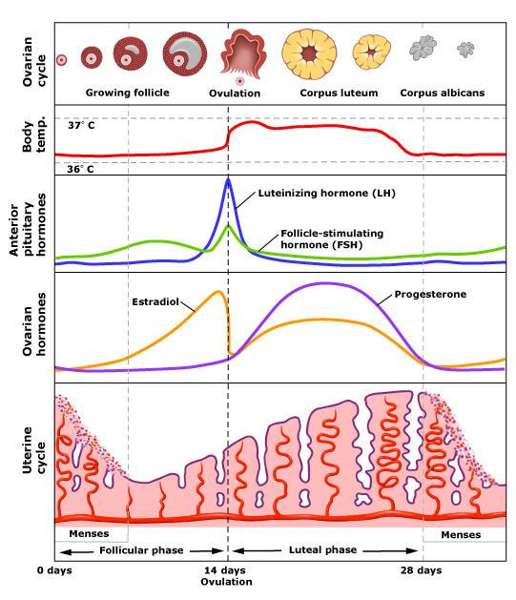
Meredith would be most likely to fall pregnant if she had sexual intercourse during the 3 days leading up to and including ovulation, so days 11-14 (assuming she ovulates on day 14). This is because fertilisation occurs in the ampulla of the fallopian tube, and it can take sperm 12-24 hours to reach the egg.
- You have an excellent relationship with both your supervising GP and Meredith. You are asked to conduct a menstrual and sexual history for Meredith prior to her appointment.
List below important questions to ask your patient.

• Age of menarche/menopause
• Date of last menstrual period
• Length of menstruation and cycle
• Regularity of cycles
• Irregular bleeding Where, when, how much? (size/number of pads), clots?
• Peri-menstrual symptoms (mood, fluid retention, breast pain, libido changes, bladder and bowel symptoms etc.)
• HPV status/Cervical screening
• Contraception/Hormonal therapy
• Menopausal symptoms
• Sexual history (include gender identification, any symptoms such as dyspareunia, post-coital bleeding)
• Urinary problems (incontinence etc.)
• Symptoms of prolapse (vaginal lump, urinary incontinence)
• Past gynaecological history (including surgery, curettage)
• Obstetric history
• Previous obstetric history
o All past pregnancies, Gravidity and parity (include miscarriages, terminations, live births, stillbirth, neonatal death, IVF)
o Previous labour and delivery (length, gestational age, baby weight, analgesia, delivery method, APGAR score, complications, perineum, breastfeeding)
• Past medical and surgical history (including specific pelvic surgery)
• Other systems review (endocrine, haematological, neurological, genetic)
• Social History (smoking, alcohol, relationships, support, activities)
• Medications (oral contraception, cause of menorrhagia?)
• Psychiatric history
• Immunisation status

FIFE (if patient is pregnant or planning pregnancy)
Feelings related to the pregnancy, especially fears
- What are you most concerned about?
- Do you have any specific fears and worries right now?
Ideas and explanation of cause of symptoms, mode of delivery etc.
Functioning – impact of the pregnancy on daily life
Expectations of the doctor, midwife, nursing staff, progress and outcome of the pregnancy

Essentially read the DP workshop on this you may have to perform this for your summative comm skills

- Three months later, Meredith comes back to the GP clinic very upset. She thinks she is pregnant, however she has been unfaithful to her husband Derek, and does not know if the baby is his. She has not menstruated for well over one month and today is 9 days since her expected first day of menses. She usually ovulates on day 15 of a 30 day cycle. Exactly 4 weeks ago (28 days) she began having sexual intercourse four times over 2 days with another man Finn Dandridge. She abstained for two days and then had sexual intercourse twice over 24 hours with Derek. Then she abstained again for one week, before having sexual intercourse with a third guy Nathan Riggs three times over 2 days. If Meredith is pregnant, who is the most likely father and explain why.

Derek is the most likely father as she had sex with in in the 24 hour time frame around ovulation. Finn is the next most likely, as sperm can live in the vagina for ~3-5 days. Nathan is unlikely to be the father as he and Meredith had sex a week after she ovulated.

4) Show on the graph the hormonal changes that occur throughout pregnancy and explain each of their roles. (Focus on Oestrogen, Progesterone and hCG)

0 | 4 | 8 | 12 | 16 | 20 | 24 | 28 | 32 | 36 | 40

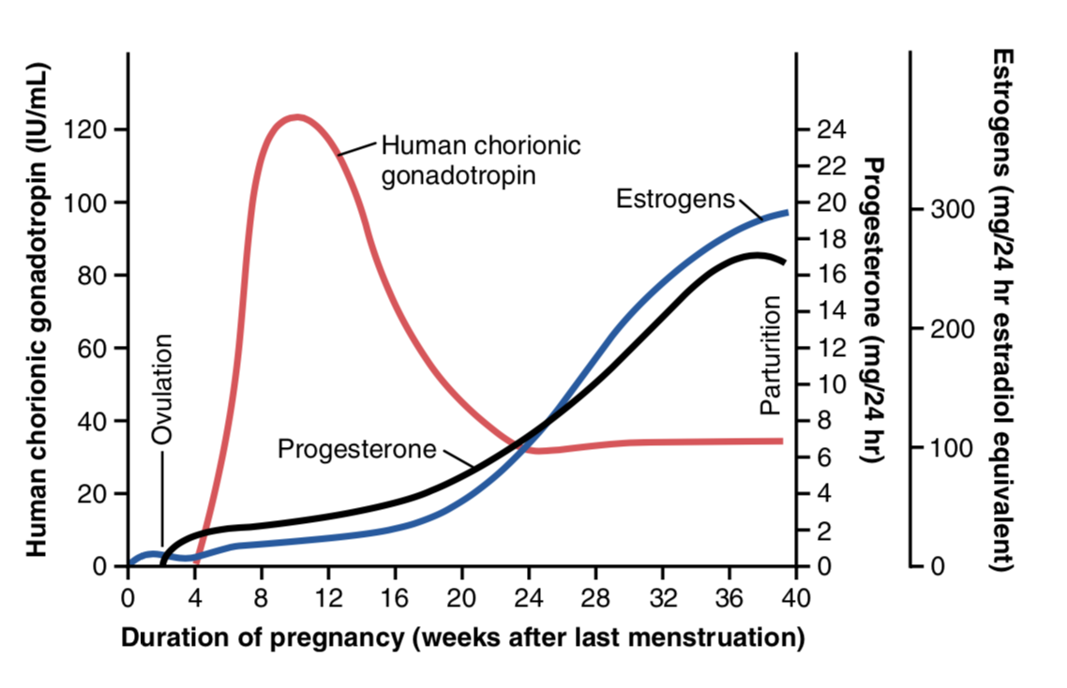

HCG: maintains the corpus luteum so that it can continue to produce enough progesterone and oestrogen until the placenta has developed enough to take over and produce them.

Progesterone:
- Involved in the secretory phase of the menstrual cycle, establishing a positive envirnoment for implanation.
- During pregnancy acts in the maintenance of pregnancy (maintains endometrium and decrease myometrial excitability (relaxing uterotubal musculature), also works to increase uterine angiogenesis (formation of new blood vessels) BUT NO VASODILATION
- Arguably the most important steroid hormone for maintenance of pregnancy

Estrogen:
- Involved in the proliferative phase of the menstrual cycle, causing growth and thickening of glands.
- During pregnancy it works to increase uterotubal muscle contraction (opposes progesterone) and increases uterine angiogenesis and vasodilation
- Important in parturition (childbirth) transition

5) How are the above hormones used to confirm pregnancy?

HCG is used. Appears early in the urine at detectable levels from its secretion by the syncytiotrophoblasts (outer layer of trophoblasts) of the developing embryo.

6) What is the ideal screening test in terms of sensitivity and specificity? How does this change for a diagnostic test?

Screening Test | Diagnostic test
HIGH sensitivity needed | HIGH specificity needed
Accurate and reliable | Accurate and reliable
Easy to implement/acceptable to patients and low risk | May be more invasive/contain more risks
Ideally low cost | May be of higher cost
Performed on asymptomatic individuals, or those ‘at risk’ of the condition | Performed on symptomatic individuals, or those at high risk

7) What is the organisation of the genetic material in a diploid and haploid cell?

Diploid cell – 46 XY or 46 XX (22 pairs of homologous chromosomes and two sex chromosomes, X or Y depending on gender)

Haploid cell – 23 X or Y (including one sex chromosome)
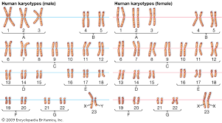

8) Explain the production of gametes (meiosis) and how genetic diversity is ensured. (focus on which cells are diploid and which are haploid)

Follows two cycles of Mitosis including

Prophase I
Metaphase I
Anaphase I
Telophase + cytokinesis I

Prophase II
Metaphase II
Anaphase II
Telophase + Cyokinesis II

The end result of meiosis is to achieve 4 haploid cells that are genetically different from one another.
This is the opposite of mitosis which is to achieve 2 diploid cells that are genetically identical
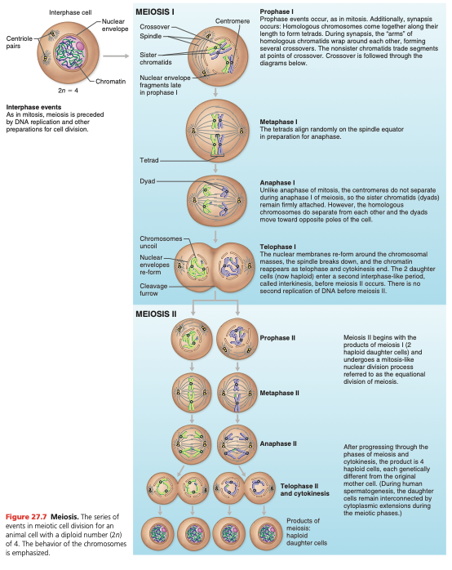
(Pic from Marieb & Hoehn – Human Anatomy & Physiology)
Genetic diversity is ensured through several mechanisms:
- Random assortment of chromosomes during meiosis I – maternal and paternal chromosomes are randomly distributed to daughter cells during oogenesis and spermatogenesis
- ‘Crossing over’ during Prophase 1, allowing different combinations of genetic material to occur in the daughter cells
- Random fertilisation of ovum by sperm – a single egg will be fertilised by one sperm on a haphazard basis – considering up to 100 million sperm are ejaculated, this leads to a huge number of different combinations of genetic material that can potentially occur
KEY
Note that in the beginning of Meiosis I the cells are diploid (two pairs of homologous chromosomes)
But at the beginning of Meiosis II the cells are already haploid (they contain one pair of ‘semi’ homologous chromosomes, ‘semi’ due to the crossing over that has occured at Prophase I.

9) Fill in the table outlining the range of abnormal events that can occur in meiosis and their consequences. (focus on the most important numerical and structural abnormalities)

Type of disorder | Example | Outcome
Numerical  Polyploid | Triploidy (69 chromosomes) | Lethal
Numerical  Aneuploid | Trisomy of chromosome 21  Trisomy 18  Trisomy 13  Monosomy of X chromosome  47 chromosomes (XXY) | Down syndrome  Edwards syndrome  Patau Syndrome  Turner Syndrome  Klinefelter syndrome
Structural
Deletion | Terminal deletion 5p  Interstitial deletion 11p | Cri du chat syndrome  Assoc. with Wilms Tumour
Inversion | Pericentric inversion 9 | Normal phenotype
Duplication | Isochromosome X (fusion of long arms with loss of short arms) | Infertility in females
Ring chromosome | Ring chromosome at 18 | Mental retardation syndrome
Fragile site | Fragile X | Mental retardation syndrome
Translocation | Reciprocal  Robertsonian | Balanced translocations cause no abnormality. Unbalanced translocations cause spontaneous abortions or syndromes of multiple physical and mental handicaps

10) Describe the different types of inheritance patterns.

Inheritance Pattern | Characteristics | Disease Examples
Autosomal dominant | Each affected person usually has an affected parent; occurs in every generation | Huntington's  Neurofibromatosis  Achondroplasia
Autosomal recessive | Both parents of an affected person are carriers; not typically seen in every generation | Sickle Cell Anaemia  Cystic fibrosis
X-Linked Dominant | Females are more frequently affected because all daughters and no sons of an affected man will be affected; can have affected males and females in same generation if the mother is affected | Hypophatemic rickets  Ornithine transcarbamylase deficiency
X-Linked recessive | Males more frequently affected; affected males often present in each generation | Hemophilia A/B  Duchenne muscular dystrophy
Mitochondrial | Can affect both males and females, but only passed on by females because all mitochondria of all children come from the mother; can appear in every generation | Leber's hereditary optic neuropathy, Kearns-Sayre Syndrome
Codominant | Both alleles are expressed as the phenotype. | ABO blood group

11) What screening and diagnostic tests are used throughout pregnancy?
SCREENING

Trimester 1 (weeks 1-13)
- 8 week dating scan + testing of the following
< Hep B, C, MMR, Dpt, syphilis, HIV
< Thyroid issues ( 5 B’s)
< Chest (breast, cardiac, lung fields)
< Preeclampsia (BP check)
< Rhesus status

Combined first trimester screening (weeks 12,13)
- Ultrasound including nuchal translucency test
< Estimates baby’s age and foetal morphology can identify major structural abnormalities
· Nuchal translucency assesses the size of the window visible behind the baby’s neck – an increased width indicates increased risk of chromosomal or genetic abnormalities
< Noninvasive prenatal testing (NIPT)
- Blood test checking for chromosomal conditions such as Down’s syndrome. Identifies 99% of babies with Down’s syndrome
- Pregnancy associated plasma protein PAPP-A

The ultrasound combined with noninvasive prenatal testing gives risk for Edwards, Patau and Down’s syndrome

Trimester 2 (13-26)
- 20 Week morph scan
< Organs fully formed (check for all anatomy)
- OGTT (24-28 weeks) – Gestational diabetes

Trimester 3
- Ultrasound 28 and 34 for high risk pregnancies

DIAGNOSTIC
- Amniocentesis or chorionic villus sampling
< Usually performed after screening tests if a chromosomal abnormality is suspected or the woman is at high risk
< Amniocentesis – sample of the amniotic fluid
< Chorionic villus – sample of the chorionic villus cells in the placenta
NOTE: these tests carry a risk of miscarriage as they require entering the amniotic sac to take the samples

https://ranzcog.edu.au/RANZCOG_SITE/media/RANZCOG-MEDIA/Women%27s%20Health/Patient%20information/Prenatal-Screening-for-Chromosomal-and-Genetic-Conditions.pdf?ext=.pdf

Meredith has a discussion with Derek about her pregnancy and voices her concerns over who the father of the child could possibly be. Meredith and Derek decide to go ahead with the pregnancy as a couple.

- If Meredith was to decide to terminate the pregnancy, would this be lawful in Queensland? Explain the relevant legislation.

Termination of Pregnancy Act 2018 (QLD)
Termination by medical practitioner at not more than 22 weeks
A medical practitioner may perform a termination on a woman who is not more than 22 weeks pregnant
Termination by medical practitioner after 22 weeks
- A medical practitioner may perform a termination on a woman who is more than 22 weeks pregnant if:
  - The medical practitioner considers that, in all the circumstances, the termination should be performed; and
  - The medical practitioner has consulted with another medical practitioner who also considers that, in all the circumstances, the termination should be performed.
- In considering whether a termination should be performed, a medical practitioner must consider:
  - All relevant medical circumstances
  - The woman’s current and future physical, psychological and social circumstances
  - The professional standards and guidelines that apply to the medical practitioner in relation to the performance of a termination
- In an emergency, a medical practitioner may perform a termination on a woman who is more than 22 weeks pregnant , without acting under subsection 1 and 2 if the medical practitioner considers it is necessary to save the woman’s life or the life of another unborn child.
Conscientious objection
If the practitioner has a conscientious objection:
- Must disclose the conscientious objection to the person
- Must refer, or transfer the woman’s care to another registered health practitioner or service who in the practitioner’s belief, can provide the requested service and does not have a conscientious objection themselves.
- DOES NOT limit any duty owed in an emergency situation

Please provide feedback for this case at:
https://forms.gle/R64a83Cf7UgRYc168

