Please note – this learning resource has been produced by the GUMS Academic Team. It is possible that there are some minor errors in the questions/answers, and other possible answers that are not included below. Make sure to check with other resources.

SCENARIO 1:
Max, a 16-year old with a severe allergy to peanuts is dared by a friend to administer his Epipen (IM adrenaline) when he is not having an anaphylactic attack.

1. Describe the various receptors adrenaline works on and contrast them to the cholinergic receptors.
- Adrenergic fibres secrete NA, cholinergic secrete Ach
Receptor types
Receptor  types | NA vs Adr | Most sympathetic target tissues | Ip3/DAG/Ca path | Excitatory
A1 | NA = Adr | Vascular smooth muscle | Ip3 and DAG increase Ca rises | Excitatory
A2 | NA > Adr | CNS, Digestive organs | Inhibits cAMP | Inhibitory
B1 | NA = Adr | Heart | Stimulates cAMP | Excitatory
B2 | Adr only | Smooth muscle – arterioles, bronchi | Stimulates cAMP | Inhibitory
Muscarinic | Ach from postgang | Cardiac & smooth muscle, glands | Various GPCRs | Depends on effector
Nicotinic | Ach from pregang & motor neurons | All postgang cell bodies, adrenal medulla, motor end plates | Open ligand-gated cation channels | Excitatory

2. What are the major drugs mimic these receptors?
Drugs which mimic
- A1 agonist – phenylephrine – nasal decongestant, constricts nasal vessels
- A1 antagonist – prazosin - antihypertensive, causes vasodilation
- B1 antagonist – metoprolol – antihypertensive, decreases HR and contractility
- B2 agonist – salbutamol – dilates bronchioles, asthma reliever
- Muscarinic antagonist – atropine – used for bradycardia, organophosphate poisoning
- Muscarinic agonist – carbachol
- Anti-cholinesterase (organophosphates) – blocks acetylcholinesterase, leading to build up of Ach
- Cholinesterase re-activators – pralidoxime/2-PAM – reactive acetylcholinesterase by cleaving phosphate-ester bond
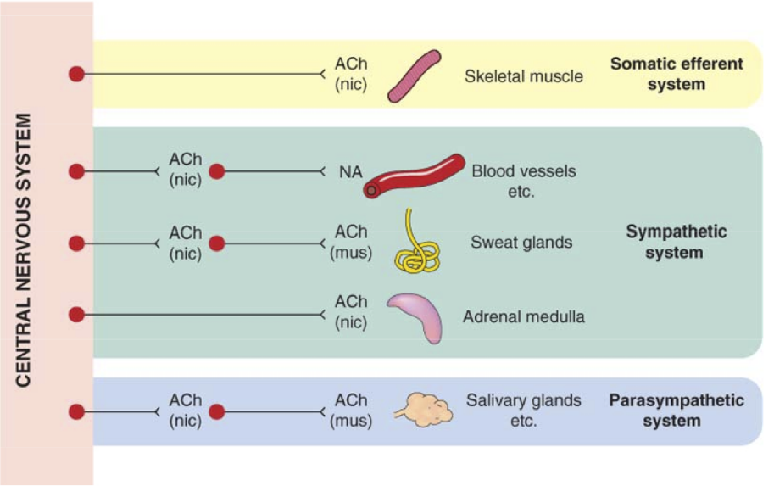
3. Max began to exhibit telltale sympathetic signs. Compare and contrast the SNS and PNS systemic effects.

Major effects:
Sympathetic | Parasympathetic
Dilated pupil | Constrict pupil
Inhibits salivation, other secretions | Increase salivation, mucus, tears
Relaxes airway smooth muscle | Constrict airway smooth muscle
Incr. HR & contractility, constricts blood vessels (except muscles, dilate due to adrenaline) | Slows heart and decreases HR
Inhibits digestion | Stimulates digestion
Stimulates glucose release in liver | Stimulates gallbladder
Secrete adrenaline/NA from adrenal gland | No innervations of liver, blood vessels, kidney
Relaxes bladder | Contracts bladder
Contracts rectum | Relaxes rectum
Ejaculation | Erection

+ DUMBELLS (diarrhoea, urination, miosis, bronchorrhoea, body fasciculations, emesis, lacrimation, lethargy, salivation) + SLUDGE (salivation, lacrimation, urination, defecation, gastric emptying, emesis)

4. Why is adrenaline routinely given by IM injection instead of orally or IV?
- Oral has high first past metabolism (explain first past metabolism as listed below)
- IV route has erratic and unpredictable distribution and very high risk as straight into blood system
- IM has a lower and more predictable distribution from the muscle than IV route
First Pass Metabolism
- When orally administrated drugs are partially or completely inactivated by the gut or liver before entering circulation
- Limits oral administration of highly metabolised drugs – higher doses needed
- Heroin and naloxone both undergo extensive first pass metabolism – therefore injected straight into bloodstream, rapidly crosses blood brain barrier

5. Explain the concept of bioavailability in regards to oral vs IM vs IV
Bioavailability = fraction of administered dose which makes it into the bloodstream
- Orally administered drugs – only a portion of the dose makes it to the bloodstream, depending on absorption and first pass clearance
- Absorption mainly affected by drug properties e.g. solubility and charge. Also by blood flow thru GIT, food consumed at same time etc
- First pass clearance is when the drug is metabolised, usually by CYP450 enzymes, after travelling to the liver via the portal vein.
- Bioavailability = F = Fg x Fh (amount absorbed x amount escaping liver extraction)
- Drugs administered intravenously have 100% bioavailability

6. Describe what agonists and competitive and non-competitive antagonists are
Antagonists and agonists work at receptor sites to either inhibit/Block or stimulate a response from said receptor. Competitive antagonists or agonists “compete” against a natural substrate for a binding site whereas a non-competitive agent binds at a different site to the endogenous substrate.

SCENARIO 2:
Mr. Roy has familial hypercholesterolemia and has been taking simvastatin, a HMG-CoA reductase inhibitor (statin), to lower his risk of CVS disease for the last 6 years. Today Mr Roy presents to his GP with coughing, fever and chest pain. The GP suspects a chest infection and prescribes clarithromycin (a macrolide antibiotic). Simvastatin is broken down via CYP450 system and clarithromycin is an inhibitor of the CYP450 pathway.

1. What concerns would you have by using these two medications together?

Clarithromycin will reduce the metabolism of simvastatin and may increase the risk of side effects and toxicity including rhabdomyolysis (explain if student don’t know what that is, which is the breakdown of muscle).

2. Explain (in brief terms) clearance (high and low hepatic and renal) by the liver and how this relates to this scenario.
Clearance
- Volume of blood cleared of a drug per unit of time – mL/min, L/hr
- Total clearance includes renal, hepatic, and other
- Excretion ratio = how much of the drug is cleared in one pass – e.g. 0.66 would indicate two thirds of the drug is cleared through the liver
- High hepatic clearance / excretion ratio indicates only a small % of a drug reaches circulation
  - Prefer to give IV or sublingually, straight into bloodstream
- Low hepatic clearance / excretion ratio – most of drug reaches system circulation
- In the case above, clarithromycin is an inhibitor of CYP450, therefore there will reduce the hepatic clearance of simvastatin resulting in a higher proportion of the drug reaching systemic circulation.

3. Explain (in brief terms) the cytochrome P450 system
The Cytochrome P450 system is a group of enzymes which are responsible for breaking down exogenous molecules including medications and toxins. Different medications can either stimulate or inhibit this system leading to potentially unwanted effects including drug toxicity or treatment failure.
For example, clarithromycin inhibits the CYP450 breakdown of simvastatin leading to simvastatin accumulation and toxicity, whereas Phenytoin (an epilepsy drug) can induce the system to break itself and other antiepileptics down faster, leading to poor seizure control.

4. List 2 options for appropriate management of Mr Roy’s condition
- Prescribe an alternative antibiotic such as a Penicillin or
- Tell Mrs. Lipo to stop taking her simvastatin till she has finished the course of clarithromycin.

SCENARIO 3:
Paramedics are called to a local park by a jogger who noticed a young female slumped over a bench. The paramedics find a driver's license and identify the female as Mrs Sims. She has fresh IV track marks on her arm and labored and shallow breathing at a rate of 4 breaths per minute. Mrs Sims is unresponsive to her name, and her eyes are dilated.

1. What is heroin?
Heroin is an opioid drug what interacts with opioid receptors in the body to give euphoria.

2. What are the major effects of opiates?
There are three main opioid receptors that mediate the effects of opioids being

Mu = analgesia, euphoria, sedation, respiratory depression, GI dysmotility and physical dependence
Kappa = Analgesia, diuresis, miosis and dysphoria
Delta = Analgesia, inhibition of dopamine release and cough suppression

They are GPCR (g protein coupled receptors) that when activated cause a variety of downstream cellular signals (mainly open K channels and inhibit Ca channels opening), with a net result of modulating the release of neurotransmitters.

There are four major effects caused by opioids
- Euphoria -> Increased dopamine released in mesolimbic system
- Analgesia -> Inhibition of nociceptive information at multiple points from the peripheral nerves to the central nervous system.
- Sedation -> Similar to analgesia, opioids upregulate inhibitory signals within the brain and reduce afferent component of pain and sensation.
- Constipation -> Opioids increase tone and reduce motility in many parts of the GI tract, done through interactions nerves supplying the smooth muscle.

3. What are some signs and symptoms of Heroin/ opioid overdose and explain why respiratory depression occurs?
There are three main signs of an opiate overdose
1. Respiratory depression (Decrease rate and tidal volume)
2. Altered mental status
3. Miosis (constriction) (Normal pupil examination doesn’t exclude opioid toxicity)

However other signs and symptoms (some being non-specific) include
- Decreased bowel sounds
- Decreased heart rate and blood pressure
- Hypothermia

Opioids inhibit nerve signal transduction in the brain including to the dorsal and ventral respiratory groups in the Pons. Specifically, mu receptors cause a diminished response to hypercapnia and a decreased respiratory response to hypoxia, leading to decreased stimulus to breathe and development of apnea.

4. What is a likely diagnosis for Mrs. Sims signs
Opioid/ heroin overdose

The paramedics decide to administer Naloxone based on Mrs. Sims signs and symptoms
5. What is naloxone and how does it work? Is a single dose sufficient?
Naloxone is an opioid receptor antagonist. It works to competitively antagonise the opioid receptors and reduce the effects of opioids in overdose. Naloxone is a short acting medication that only lasts 5 min. Therefore, continued administration is required as IV drugs such as heroin can persist in the body and effects of overdose can reoccur once naloxone wears off. A naloxone drip may be initiated in hospital.

The paramedics decide to transport Mrs. Sims to hospital for observation and continued naloxone therapy. Whilst in hospital Mrs. Sims expresses her desire to get clean. She is referred to the ATODS (Alcohol, tabacco and other drugs service) and it is decided that as Mrs. Sims mainly uses heroin, methadone is to be initiated.

6. What is Methadone
Methadone is a long acting (24 hours) opioid that is used to replace heroin to reduce withdrawal symptoms, reduce craving for opiods, reduces the euphoric effects of illicit opioid use (due to maintaining high levels of opioid tolerance).

7. Why would this help Mrs. Sims with her addiction to heroin (also explain half-life and its relevance)

- Methadone, being an opioid, works at the same receptors as heroin and hence satisfies the bodies cravings for heroin in addicted persons.
- Methadone has a long half life and hence does not lead to drastic drops in drug levels leading to addiction.
- Methadone has a stronger binding affinity as well, therefore will stay attached to the receptors and other opioids e.g. heroin cannot bind.
Half-Life
- Time taken for plasma conc. of a drug to decrease to 50% its original
- Clinical importance – drugs with short half-lives need to be given more often (drugs
- given approx every 1-2 half-lives)
  - Pharmacokinetics of drugs can be altered – slow release formulations
- Important to note that some drugs can exhibit actions longer than their stated half-lives
- due to secondary cellular changes after drug eliminated, or actions of
- metabolites
- Heroin – half-lives approx 10 mins – but metabolised to morphine which has
- significantly longer half-lives 3-4 hrs
- Naloxone – average half-lives approx 60 mins

8. Explain the clinical definitions of tolerance, dependence and withdrawal and relate them to Mrs. Sims situation
Tolerance
- Decreased response to a drug, requiring increased dose to achieve same/desired effect
- Cross tolerance – tolerance to drugs within the same class
- Tachyphylaxis – sudden onset drug tolerance which is not dose dependent
- Mechanisms include change in receptors (phosphorylation), down regulation of
- receptor numbers, induction of enzymes (CYP450), receptor desensitization
- (decoupling of G-proteins), changes in cellular pathways (cAMP production)

Dependence
- Physical – compulsive need to use a substance repeatedly in order to avoid withdrawal symptoms
- Person is dependent on the drug to function ‘normally’, due to adaptive changes in receptors, transporters mentioned above

Withdrawal
- Physical and psychological reactions when the body is deprived of substances.
- Effects seen from cellular changes above and changes in homeostasis.

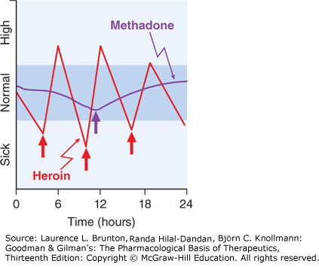

ADDITIONAL QUESTIONS
Describe the mechanisms that remove or destroy the neurotransmitter after its release, giving examples of the various mechanisms.
- Degradation
  - Enzymes in synaptic cleft break the NT down into substances which have no effect on receptors. These substances may or may not be recycled to make more NT. E.g. acetylcholinesterase breaks down Ach 🡪 choline and acetyl CoA
- Reuptake
  - NT which doesn’t bind to receptor can re-enter the presynaptic cell through channels in the membrane – i.e. it gets recycled
- Auto receptors
NT can bind to receptors located on the pre-synaptic membrane. If excess NT binds to these, it signals the neuron to stop releasing NT by opening less Ca channels

Explain how drugs exert their effects through receptors for endogenous ligands, using heroin and naloxone as examples
- Binding of a ligand to a receptor initiates a conformational change which in turn activates a
- cellular response
- Affinity = binding to the receptor
- Efficacy = stimulating the receptor, producing effect
- Agonists = drugs that stimulate receptors and mimic endogenous messengers and produce
- an effect e.g. heroin
- Antagonists = drugs that block receptors and prevent signal being sent or reduce intensity.
- Can also block agonists from binding e.g. naloxone

Please provide feedback for this case at: https://gums2020.typeform.com/to/e0h7US

