Please note – this learning resource has been produced by the GUMS Academic Team. It is possible that there are some minor errors in the questions/answers, and other possible answers that are not included below. Make sure to check with other resources.

Scenario 1
Lizzo is a second year uni student who presents to the GP practice with trouble sleeping and irritability, she attends with her mother.

What further information on history would you want to ask/look for from a psychiatric perspective?
Might be easier to break it down for students into the following categories
- MSE
- History of presenting complaint (HPCx)
- Past medical history/family history
- Medications

MSE
This is a vital aspect of all psychiatric assessments and provides useful information which can confirm or rule out a diagnosis
- General description
  - Appearance -> general description of patient’s appearance (body build, posture, clothing, grooming, hygiene
  - Behaviour -> appropriateness both motor and psychomotor
  - Attitude -> how the patient responds to the interviewer
- Mood and Affect
  - Mood -> How their emotional state is
  - Affect -> how the patient conveys their emotional state (is this congruent or incongruent with their mood?)
  - Appropriateness -> Appropriateness of matter discussed
- Speech -> volume, tempo, modulation and quality of speech
- Thought
  - Thought form -> the way thought content is expressed – quantity of ideas (pressured thought, poverty of ideas) and how the thoughts are produced (logical/linear, fragmented, irrelevant)
  - Thought content -> Look for preoccupation, obsession, overvalued ideas, suicidal/homicidal ideation and thoughts of deliberate self-harm
- Perception
  - Hallucinations – reported hallucinations and/or seen to be responding to non-apparent stimuli during the interaction
  - Illusions
- Sensorium and cognition
  - Alertness and level of consciousness
  - Orientation -> time, place, person
  - Short-term memory -> Recall of items mentioned in the beginning of interaction
  - Long-term memory -> Remote events
  - Concentration -> Ask the patient to subtract 7 from 100, spell world backwards
  - General knowledge -> look at language used to answer recent event questions
- Judgement and insight
  - Judgement -> capacity to behave appropriately
  - Insight -> Inner awareness (nil, partial, complete)

HPCx
- Explore the nature of the issue and patient’s perception
- Changes in mood?
  - How would you describe your mood recently? How long?
- Precipitating events
- Excessive anxiety or worry?
- Sleeping patterns – insomnia, hypersomnia
- Appetite
- Hallucinations
- Delusions
- Feelings of guilt/worthlessness
- Previous episodes (see psychiatric hx)
- Screen for manic symptoms – periods of heightened mood, reduced need for sleep, goal-oriented activities, risk-taking behaviour
- Screen for risk to self and others

PMHx + Medication history
- Past psychiatric history
  - Diagnosis and treatment (pharmacological and non-pharmacological)
  - Inpatient vs outpatient management
- Medications
  - Consider recent changes or ceased medications
  - Consider what worked before
  - Consider compliance and factors impacting on it (e.g. adverse effects)

Family history
- Any psychiatric illnesses in the family
- Has any member of the family died by suicide (careful with wording)

Social Hx (important part of psychiatric history!)
- Smoking, alcohol, illicit drug use
- Employment/financial circumstances
- Home circumstances
- Hobbies and impact
- Explore childhood (abuse, level of care)

On further questioning from Lizzo and her mum you get the following information. She would go days without sleeping and had difficulty concentrating at uni. She started spending a lot of money on strange online shopping purchases (e.g. 18 miniature shrek figurines). When her parents discovered the problems, they brought her in for evaluation. Lizzo did not feel that anything was wrong. She felt that she had just made several poor decisions, like anyone her age.

What is your preliminary diagnosis and how did you come to this conclusion?
DIGFAST
D – distractibility
I – irresponsibility or loss of social inhibitions (e.g. reckless behaviour, aggressiveness, hostility)
G – grandiosity or heightened self-esteem
F – flight of ideas or racing thoughts
A – increased goal directed activity (sexually, at work or socially)
S – decreased need for sleep
T – talkativeness/pressured speech
PLUS significant dysfunction in activities of daily living (ADL) (for mania) or not significant dysfunction (for hypomania)
The diagnosis therefore is most likely acute mania
Consider timeline as well (>7 days for manic episode)

What are some complications of her diagnosis?
- Psychosis
- Suicidality
- Marked functional impairment
- Damage to reputation and assets

How is mania treated acutely and long term?
Acute mania: treat with atypical antipsychotics (olanzapine, quetiapine) – lithium can be used when mania is mild and patient is not agitated
Long term: lithium

Lizzo is prescribed lithium as a mood stabilizer. The GP explains that lithium has a ‘narrow therapeutic index’ and this means she will have to have regular monitoring of the drug.
What does this mean and what kind of monitoring will need to be done?
The therapeutic index is the LD₅₀/ED₅₀ where the ED₅₀ is the potency (dose required to produce 50% of the maximum possible response) and the LD₅₀ is the dose that is lethal in 50% of the test population. The higher the lethal dose in comparison to the effective dose, the safer the drug. For lithium, the narrow therapeutic index means that the lethal dose is close to the effective dose.
Lithium levels and renal function are the key things to monitor. Lithium causes nephrotoxicity and lithium toxicity is also caused by impaired renal function if the kidneys are unable to clear the lithium.

Scenario 2
Jimmy Mcavoy is a 23 year old man who is brought to the GP by his sister who is concerned about his increasingly bizarre behaviour. She says he talks about voices no one else can here and the voices tell him to ‘barricade the house’. He also believes that ‘someone is watching him’. His sister thinks that he is having a psychotic episode.
She asks you ‘what are the main categories of symptoms that define psychosis and some examples of each?’
Positive symptoms | Negative symptoms | Disorganized
Hallucinations (auditory is most common type)  Illusions  Delusions | Flat affect  Alogia  Anhedonia  Apathy  Withdrawal | Loose associations  Word salad  Neologisms  Tangential speech

Discuss the difference between an illusion vs delusion vs hallucination.
Delusion: fixed, false beliefs which cannot be corrected by logic and are not consistent with the culture and education of the patient
Hallucination: false sensory perceptions experienced without real external stimulus e.g. seeing a goblin sitting next to you, when nothing is actually there. Can be visual, auditory, tactile, taste.
Illusions: Misperception of real external stimulus. E.g. looking at a cloud formation and seeing a goblin

Jimmy is diagnosed with schizophrenia and is commenced on olanzapine. What class of drug does olanzapine belong to and what are its major side effects?
Olanzapine is an atypical (second gen) antipsychotic
- Metabolic side effects very common with second generation antipsychotics: dyslipidaemia, weight gain, hyperglycaemia and diabetes mellitus need to monitor waist circumference, fasting glucose, lipid profile and blood pressure
- Anticholinergic side effects: dry mouth, constipation, urinary retention
- Cardiovascular events: QT prolongation and cardiomyopathy
- Sexual side effects: reduced libido, erectile dysfunction, anorgasmia
- Sedation: due to antihistamine action
- Hyperprolactinaemia
  - Dopamine secretion from the hypothalamus inhibits prolactin secretion anti-dopaminergic activity therefore removes the inhibition of prolactin secretion. (More on this in P4P.)
- + many more - antipsychotics are a pharmacological nightmare

Jimmy’s sister had heard about another drug used to treat schizophrenia called haloperidol, compare its drug class to that of olanzapine drug class in terms of:
 | Typical antipsychotics (first generation) | Atypical antipsychotics (second generation)
Drug examples | Haloperidol, droperidol | Olanzapine, Clozapine**, risperidone, quetiapine
MOA | Strong dopamine receptor antagonism | Weaker dopamine receptor antagonism and antagonists for serotonin, histamine and alpha adrenergic receptors
Adverse effect profile | YIELD  - Extrapyramidal side effects* - more common  - Tardive dyskinesia  - Hyperprolactinemia gynecomastia, lactation  - Prolonged QT interval risk of arrhythmias  - Neuroleptic syndrome  - Metabolic and anticholinergic effects less pronounced | YIELD  - Metabolic effects most prominent (weight gain, hyperglycemia, dyslipidemia)  - Sedation  - Prolonged QT interval  - Hyperprolactinemia (less than typicals)  - EPSE less common  - Anticholinergic and anti-sympathetic effects  - Neuroleptic malignant syndrome
Indications | Generally used as second line aside from acute presentations of the following psychiatric disorders  - Schizophrenia  - Bipolar disorder  - Acute psychosis  - Delirium | More used first line and are the only antipsychotic medications with evidence for long-term treatment in the following psychiatric disorders  - Schizophrenia  - Bipolar disorder  - Acute psychosis  - Delirium  - Anxiety disorders  - Huntington’s disease
Contraindications | Parkinson’s - Any antipsychotics may aggravate the condition due to dopamine antagonism  Lewy Body dementia - any antipsychotics (even low dose) can cause deterioration in cognitive and motor function + increase agitation  Seizures - use with caution may lower seizure threshold

*EPSE
- There are 4 EPSEs (ADAPT - acute dystonia, akathisia, parkinsonism, tardive dyskinesia):
- Are a collection of movement disorders that are typically due to disruption of dopaminergic pathways in the basal ganglia, resulting in
  - Bradykinesia
  - Rigidity
  - Dystonia
  - Athetosis (abnormal muscle contraction causes involuntary writhing movements)
  - Chorea
  - Ballismus (spontaneous involuntary movements, muscular weakness and incoordination of movements of the proximal extremities)
  - Akathisia
  - Tics and tremors
- Acute dystonias are more likely to occur within weeks of starting an antipsychotic and is reversible on drug cessation, whereas tardive dyskinesias often develop after months or years and is often irreversible.
- 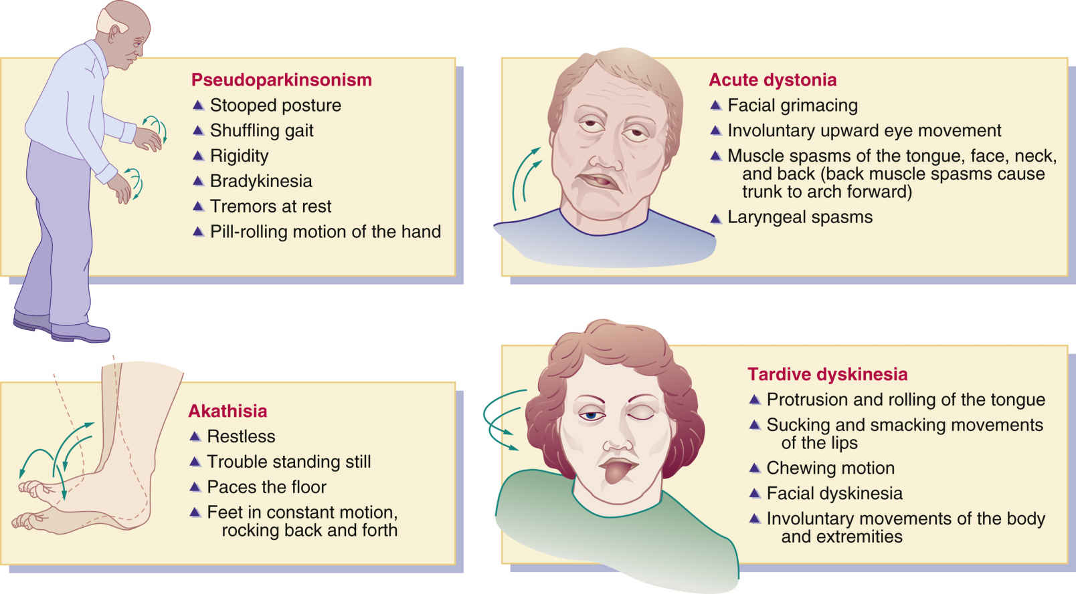

**Clozapine requires extra monitoring due to neutropenia and agranulocytosis but is the gold-standard treatment for schizophrenia. Often requires inpatient observation and up-titration when started.

Two weeks after Jimmy’s acute psychosis, he comes to see the doctor because of difficulty with movements and a tremor. Neurological examination shows a shuffling gait, increased tone in the upper extremities and a tremor of the hands which improves with activity. The mental status examination is normal.
- What is going on here and what is the mechanism?
This is drug-induced pseudoparkinsonism (bradykinesia, muscle rigidity, resting tremor) caused by anti-dopaminergic activity of antipsychotic drugs. NB: typical antipsychotics are thought to be worse for extrapyramidal side effects but they can occur with all antipsychotics

Scenario 3
Sarah Tonin, a 20 year old medical student presents to her GP with the following a 5 week history,
- A depressed mood almost everyday
- Insomnia

List some other questions on history you could ask to make a provisional diagnosis of depression.

SIG E CAPS
S - Sleep
I - Interest (anhedonia if none)
G - Guilt
E - Energy
C - Concentration
A - Appetite
P - Psychomotor agitation or retardation
S - Suicidal ideation

Need 5 (or more) of the above to be present during the same 2-week period and at least one of the symptoms must be depressed mood or loss of interest/pleasure (anhedonia)
No history of mania or hypomania
Symptoms not better explained by another medical condition (e.g. hypothyroidism)
Symptoms not better explained by another psychiatric condition (e.g. schizophrenia)
Consider the context – e.g. depressed mood due to normal grief or severe illness

You discuss with Sarah some of the treatment options, she is curious as to which medication she will be put on. Fill out the following table and state which of the drugs she is most likely to be given.

Drug class | Examples | Mechanism of action | Side effects (not exhaustive - the most important ones are bolded)
Selective Serotonin Reuptake Inhibitors (SSRI) | Citalopram  Escitalopram  Fluoxetine  Fluvoxamine | selectively inhibit the presynaptic reuptake of serotonin | Autonomic effects – nausea, diarrhoea, dry mouth, sexual dysfunction, sweating  Mental state changes – agitation, insomnia, drowsiness, dizziness, anxiety  Neuromuscular effects – tremor, weakness, myalgia  Other – headache, SIADH ( hyponatremia), serotonin syndrome, mania (in people with bipolar disorder)  CVS – prolonged QT interval (some), palpitations, tachycardia, hypotension
Tricyclic Antidepressants | Amitriptyline  Clomipramine | Inhibit reuptake of noradrenaline and serotonin into presynaptic terminals  (Also block cholinergic, histaminergic, α-1 adrenergic and serotonergic receptors but unrelated to therapeutic effect as an antidepressant) | Anticholinergic side effects - dry mouth, blurred vision, mydriasis, decreased lacrimation, constipation, urinary hesitancy or retention  anticholinergic delirium  Adrenergic effects – tremor, diaphoresis, sinus tachycardia  Α-1 antagonism – Orthostatic hypotension, sexual dysfunction, cognitive impairment  Antihistamine – sedation, weight gain  Other cardiac effects - prolonged QT interval, arrhythmias, impaired conduction
Serotonin and noradrenaline reuptake inhibitors (SNRI) | Desvenlafaxine  Duloxetine | Inhibit serotonin and noradrenaline reuptake. | Similar profile to SSRI  Nervous system – insomnia, dizziness, headache, blurred vision, mydriasis, tremor, weakness, sweating  GI – Nausea, dry mouth, constipation, decreased appetite  CVS effects – increased BP, orthostatic hypotension, tachycardia, palpitations  Sexual Aes - sexual dysfunction, decreased libido  Other – rash, serotonin toxicity, hyponatremia
Monoamine oxidase inhibitors (MAOI) | Phenelzine  Tranylcypromine  (Moclobemide – MAO-A selective) | Nonselective MAOIs irreversibly inhibit monoamine oxidases A and B (MAO‑A and MAO‑B), increasing the synaptic concentrations of adrenaline, noradrenaline, dopamine and serotonin. | Orthostatic hypotension  Weight gain  Sleep disturbances (often insomnia)  Headache, fatigue  Mental state changes – drowsiness, fatigue, agitation  Neuromuscular – tremors, twitching, myoclonus, hyperreflexia, weakness  Autonomic – dizziness, constipation, dry mouth, sexual dysfunction  Serotonin toxicity  Hypertensive crisis (due to “tyramine cheese reaction” – rare)
Atypical antidepressants | Mirtazapine | Selective a2-adrenergic antagonist and serotonin (5-HT2 and 5-HT3) receptor antagonists  Also H1 antagonist | Increased appetite and weight gain  Sedation  Increased serum cholesterol and triglyceride levels  Dry mouth
(I’ve tried my best to group them! Psychiatric drugs have lots of side effects making them difficult to remember. Grouping by system or action (e.g. noradrenergic, anticholinergic etc.) can help.)

NOTES:
- As a general guide, side effects are usually worse in the 1st week of starting, then should gradually decrease after 2 weeks. Starting at low doses and stepping up the dose slowly may reduce their impact.
- A delay in onset of response of at least 1 to 2 weeks usually occurs with all antidepressants, and full benefit may not occur for up to 4 to 6 weeks or even longer in some cases. (This is a common MCQ…)
- Antidepressants are associated with withdrawal effects
  - Some people experience withdrawal effects after missing 1 or 2 doses, especially when using drugs with short half-lives. Other risk factors for withdrawal may include high doses and long treatment courses.
  - At the end of a treatment course, taper antidepressant over several weeks and monitor for withdrawal symptoms; this can minimise the likelihood of relapse as well as withdrawal.

According to ETG
First line is
- SSRI
- Mirtazapine
Second line is
- SNRI
Third line (treatment resistant)
- MAOI (reversible)
- Tricyclic

FOR REFERENCE: Management According to the RANZCP
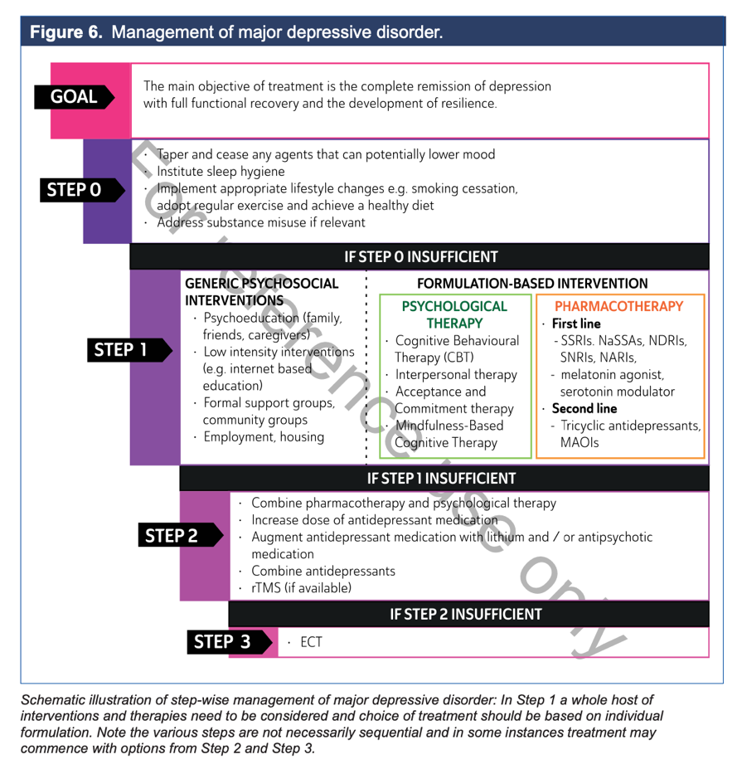
A detailed but useful resource for the management of mood disorders is available at https://www.ranzcp.org/files/resources/college_statements/clinician/cpg/mood-disorders-cpg.aspx. It is very detailed and this is unnecessary for BMB… but it has some good tables for comparisons of different mood disorders and treatments. (…May be good for your mental health rotation next year or for those that are interested!)

Please provide feedback for this case at: https://forms.gle/R64a83Cf7UgRYc168

