Please note – this learning resource has been produced by the GUMS Academic Team. It is possible that there are some minor errors in the questions/answers, and other possible answers that are not included below. Make sure to check with other resources.

Case 1

Jane is a 49 year old office worker. She presents to her GP practice complaining of joint pain. Being the good medical student that you are, you take a thorough history from Jane while the GP finishes up with another patient.

What are some differential diagnoses for her joint pain?
- Trauma (history of an injury)
- Osteoarthritis
- Rheumatoid arthritis
- Systemic lupus erythematosus
- Gout
- Reactive arthritis
- Post-viral arthritis
- Psoriatic arthritis
- Septic arthritis
- Many others

Explain briefly the differences between RA and OA.

 | Osteoarthritis | Rheumatoid arthritis
Broad classification of type of joint disease | Degenerative joint disease | Inflammatory joint disease
Joints typically affected | Weight-bearing joints – Hip, knee  PIP, DIP, first CMC (not MCP)  Lumbar and cervical spine  Rare in ankle, PIP or wrist  Usually asymmetrical | Typically smaller joints  Hands – MCP, PIP (spares DIP) Feet – MTP  Wrists, elbows, ankles  Rare in DIP, CMC and axial skeleton  Typically symmetrical
When does the joint pain occur? | Worsening with movement / weight bearing/extremes of motion  Pain relieved with rest, unless advanced OA | Pain with range of motion and at rest  Pain/stiffness may be relieved with activity
Other signs and symptoms | Morning stiffness < 30 mins Joint swelling  Limited range of movement (both active and passive movement)  Heberden’s and Bouchard’s nodes  Older patients, obese  +/- Hx of injury or trauma/joint overuse  Look up other features you would look for on physical examination | Prolonged morning stiffness >30 minutes improves with movement (not specific to RA – good indication of inflammatory joint conditions)  Articular inflammation – swollen, warm joints  Rheumatoid hand – Swan neck, Boutonniere, Hitchhiker deformities; ulnar deviation of fingers (all advanced)  Fatigue, malaise, other constitutional sx  Low Hb (chronic inflammation can suppress bone marrow)  Joint swelling  Can involve lungs, heart, haematological and vascular system also (extraarticular manifestations)  Positive family hx  Look up other features you would look for on physical examination
Pathogenesis (and what structure in the joint is damaged) | Chronic mechanical stress and age-related decrease in proteoglycans  Articular cartilage degeneration and inflammation joint space narrowing and thickening of the subchondral bone | Autoimmune disease inflammation (activation of CD4+ T cells against interstitial tissue proteins) inflammation, angiogenesis and proliferation pannus and synovial hypertrophy invasion, progressive destruction and deterioration of cartilage and bone
Features on X-ray | ACRONYM: “LOSS”  Loss of joint space (irregular)  Osteophytes (new bone synthesis)  Subchondral sclerosis  Subchondral bone cysts | Early – none  Late – juxta-articular osteoporosis, cartilage and/or subchondral bone destruction, subluxations/deviations at joint
Features on aspiration of joint fluid | Not inflammatory | Raised inflammatory markers
Principles of management | Weight loss  Regular low-impact exercise  Simple analgesia  May consider glucocorticoid injections or surgery downstream | Early diagnosis to prevent disability  Early and aggressive treatment disease-modifying anti-rheumatic drugs  Involvement of allied health (physio, OT) to maintain function  Management of acute attack with anti-inflammatory therapies for symptomatic relief

Are the following factors risk factors for OA, RA or both?
- Obesity (OA)
- Female gender (RA, OA)
- Family history (RA)
- Congenital joint deformities (OA)
- Type 1 diabetes mellitus (RA – other autoimmune diseases are risk factors)
- Older age >50 (OA)
- Previous joint injury (OA)
- Smoking (RA)
- Manual labour (OA)

The doctor orders a large number of blood tests (including but not limited to):
- Antinuclear antibody (ANA)
- Rheumatoid factor antibodies
- Anti-CCP (cyclic citrullinated peptide) antibodies
- Uric acid
- Ross river virus serology (IgM)
- Ross river virus serology (IgG)
- Barmah Forest virus serology (IgM)
- Barmah Forest virus serology (IgG)

From the thorough history you took earlier, you know that Sally’s joint pain is predominantly in the MCP and PIP joints in her hands, her wrists and her elbows, but sparing the DIP. She has recently noticed some pain in her ankle. Her joint pain has been ongoing for one year. She reports often feeling tired and unwell and complains of morning stiffness that lasts for longer than 1 hour each day. Sally’s blood tests results show elevated levels of anti-CCP and rheumatoid factor, elevated ESR and CRP.
What is the most likely diagnosis, and why?
Rheumatoid arthritis
Clinical features:
- Joint pain affecting small joints in the hand, wrists and elbows
- Spares DIP
- Morning stiffness >30 mins each day
- Feeling generally unwell
Investigation findings:
- Positive anti-CCP and RF increase the likelihood of RA
- Elevated ESR and CRP are non-specific markers of inflammation that support the diagnosis given the other history and findings
FOR REFERENCE: Diagnostic criteria for RA (probably not too relevant to remember specific details, but be aware):
- Inflammatory arthritis involving three or more joints
- Positive rheumatoid factor (RF) and/or anti-citrullinated peptide antibody
- Elevated CRP or ESR
- Diseases with similar clinical features have been excluded (particularly psoriatic arthritis, acute viral polyarthritis, polyarticular gout or calcium pyrophosphate deposition disease, and systemic lupus erythematosus (SLE).
- The duration of symptoms is more than six weeks

Explain what an elevated CRP and ESR indicates.
Both are non-specific markers of inflammation. It is hence important to consider the clinical context when interpreting these markers.
- CRP = c reactive protein, an acute phase protein produced by the liver as part of inflammatory response. Note: this takes at two days to change.
  - CLINICAL APPLICATION: Often CRP is tested every second day to monitor inflammation and look at the trend. It drops relatively quickly after inflammation passes making it valuable in monitoring treatment response.
  - It will not be raised immediately in acute inflammation/infections so consider the timeline of illness.
- ESR = erythrocyte sedimentation rate, the rate at which erythrocytes will settle in the bottom of a tube of uncoagulated blood. In states of inflammation, there is more fibrinogen, so the erythrocytes fall quicker (ραισεδ ESR).
Since you are a great student, you have studied all themes in med school equally. The doctor is keen to test you so hands you a study (excerpt below).

The sensitivity and specificity of anti-CCP reactivity for the diagnosis of rheumatoid arthritis (RA) were 66.0% and 90.4%, respectively. This compared with the sensitivity and specificity of RF for RA at 71.6% and 80.3%.

What does this mean in the context of Sally’s results?
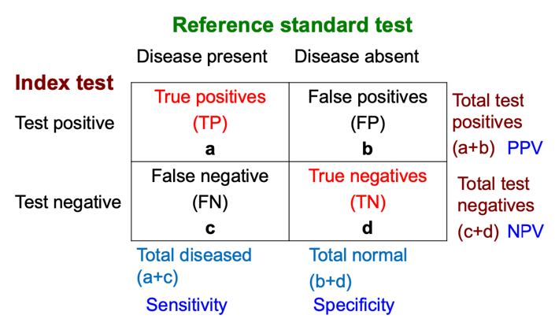
From the DHC “Formative Exercises: Screening and Diagnostic Tests” lecture by Dr Padmini Subramaniam (2018)
Remember:
- Sensitivity is the proportion of patients with the disease, with a positive result. A test with a high sensitivity is effective at ruling out a disease.
- Specificity is the proportion of patients without the disease, with a negative result. A test with a high specificity is effective at ruling in a disease.
Sensitivity
- 66% of patients with RA will have a positive anti-CCP
- 71.6% of patients with RA will have a positive RF
- A positive anti-CCP and RF increases the likelihood of a diagnosis of RA.
Specificity
- 90.4% of patients without RA will have a negative anti-CCP
- 80.3% of patients without RA will have a negative RF
- A negative anti-CCP and RF decreases the likelihood of a diagnosis of RA.
- However, some patients without RA may still have positive levels of these antibodies.

NOTE: The take home message here is that in rheumatology there are a number of antibodies and blood markers that are investigated. Each has their own specificity and sensitivity. The implication of this is that the presence of absence of these markers alone does not necessarily rule in or out certain diagnoses. It is important to consider these investigations together in the context of the patient’s clinical presentation.

You also notice Sally’s Haemoglobin level was low. In the context of her presentation, why might this be the case?
Chronic inflammationliver upregulates production of cytokines and hepcidin
- Reduced iron release from macrophages + reduced intestinal iron absorption = less iron available systemically (this is so there is less iron for bacteria)
- Also leads to less erythropoiesis in bone marrow and shortened RBC survival low Hb
This leads to fatigue and other symptoms of anaemia. This is an anaemia of chronic disease.

What diagnosis might a markedly elevated anti-nuclear antibody increase the likelihood of? What are some clinical features of this disease?
Various autoimmune conditions, including systemic lupus erythematosus.
Typical features:
- Seen in women of child-bearing age
- Symptoms:
  - Constitutional symptoms
  - Skin involvement – malar rash, Raynaud phenomenon
  - Arthritis (symmetrical polyarthritis pattern) and arthralgia
  - May involve other systems including haematological, kidneys, heart, lungs, vascular and neurological systems
- Ix: Positive anti-dsDNA and anti-Sm antibodies (specific but not sensitive), raised inflame markers, decreased complement levels
- Rx: Managed with lifestyle changes (stop smoking, diet, exercise), glucocorticoids (for induction of remission) and hydroxychloroquine (for maintenance) and topical agents (skin manifestations)

What diagnosis does an elevated uric acid indicate the likelihood of? What might be the typical presentation of a patient with this disease?

Gout
Typical features:
- Acute severe single joint pain, often affecting the big toe (red, hot, tender ++++) decreased ROM, swelling, warmth
- +/- history of previous flares
- More common in males
- Aspiration (if performed) shows urate crystals, negative gram stain (excluding septic arthritis), high WBC count
- Associated with alcohol intake, high purine intake (e.g. red meat), dehydration, chronic renal insufficiency and certain medications (aspirin, thiazides, loop diuretics etc.)
- Acutely managed with immunosuppressing agents, adequate analgesia, timely administration of colchicine and exclusion of septic arthritis
- Managed chronically with lifestyle changes and urate-lowering therapy (e.g. allopurinol – timing important (after anti-inflammatory therapy and acute flare management))

What is the importance of asking a patient presenting with joint pain about their travel history?
Arthritis can be caused by viruses such as Ross River virus (RRV) and Barmah Forest virus (BFV).
For reference:
Typical features of RRV include fever, polyarthritis (wrist, knees, ankles, fingers; symmetrical) and a maculopapular rash (involving limbs and trunk)
- Transmitted by mosquitoes
- Widespread across Australia (first described in the north)
- Arthralgia can persist for months
- Outbreaks typically occur during summer and autumn months
- Barmah Forest Virus is similar clinically but with a more predominant rash compared with arthralgias and is generally seen as less severe

What is the significance of the IgM vs IgG results for Ross River Virus serology and Barmah Forest virus serology?
- IgM indicates a recent infection (which would be expected in the case of post-viral arthritis)
- IgG indicates a past infection
  - Remember: “IgG for GONE”
Complete the table to explain the rationale for using the following medications to treat rheumatoid arthritis.

Medication | Class of Drug | Mechanism of action | Rationale for use in RA
Prednisolone | Corticosteroid | Anti-inflammatory and immunosuppression (via binding to intracellular receptors) | Reduce inflammation  Symptom relief during bridging
Methotrexate | DMARD = disease modifying anti- rheumatic drugs  (Immunosuppressant) | Anti-inflammatory and immunosuppressing (use in autoimmune disease)  Inhibits dihydrofolate reductase (folic acid antagonist) (use in cancer therapy) | Reduce inflammation AND  decreases disease progression  Taken once a week

You prescribe Sally methotrexate. She returns to you 3 weeks later stating that it is not working.

What would you say to Sally? What could you have done differently?
- Explain that the methotrexate can take up to 12 weeks to begin showing effects
- You could have prescribed her a corticosteroid as bridging therapy for symptomatic management, before tapering. Do not use the corticosteroid long term.
- It is important to note that corticosteroids may provide symptomatic relief but do not prevent disease progression in RA.

Sally tells you she and her partner are about to start trying to fall pregnant.

What would you say to her?
Methotrexate is teratogenic and needs to be stopped 3 months prior to conceiving
- Methotrexate is a folic acid antagonist, and folic acid is vital for neural development during pregnancy. Lack of folic acid can lead to conditions such as spina bifida.
- A folic acid supplement is recommended in all couples trying to conceive and during the first trimester.
Can manage her RA with sulfasalazine (another DMARD).

Case 2

Martha is a 79 year old woman who is brought into the Emergency Department by ambulance following a fall while showering at home. Martha says that she slipped over and fell onto her right hand and bottom, but did not hit her head. She complains of worsened back pain (she has chronic back pain from a previous car accident) and right wrist pain, which limits movement.

Review the basic approach to examining any joint. What are the important things to assess when examining a hand/wrist post-trauma?

OSCE Style
Introduce self and wash hands
Explain, seek and obtain consent
Look – asymmetry gross deformity, scars, inflammation, signs of infection, open wounds/injuries, gait (lower limb)
Feel – soft tissue (temperature, swelling), bony tenderness/disruption, joints
Move – active and passive ROM
Special tests – joint/ddx dependent
- Hand and wrist – Carpal Tunnel tests (Tinels, Phalens), scaphoid tenderness, pincer grip, opposition
- Elbow – medial and lateral epicondylalgia
- Shoulder – rotator cuff tests, scapula winging, anterior instability
- Hip – FLAIR, FABER
- Knee – PCL (posterior drawer and sag), ACL (Lachman’s, anterior drawer), meniscal (Thessaly, Apley’s, MacMurray’s), patella apprehension
- Ankle and foot – palpate Achilles, Simmonds
Neurovascular assessment – motor (may be limited by pain) and sensory, peripheral pulses

Principles
Examine joints above and below – consider injuries elsewhere
Any x-rays require 2 images in 2 different planes to assess for fracture
Always assess neurovascular status distally after injuries

Martha has an x-ray and is diagnosed with a Colles fracture of her right wrist. What is this and what are the main potential complications?

Colle’s fracture is an extra-articular fracture of the distal radius resulting in posterior (dorsal) displacement of the distal segment. Often seen in elderly and/or osteoporotic females following a FOOSH injury. Produces a “dinner-fork” deformity of the hand on gross inspection.
Potential complications: damage to EPL, damage to superficial radial nerve (what would this look like clinically?)

Based on factors in the scenario, explain why Martha is more likely to present to ED with this presentation compared to her 46 year old son Marcus.

Older Age
Increased risk of falls due to:
- Various chronic health conditions
- Muscle weakness
- Poor balance or vision
- Polypharmacy
Age-related decreases in bone density
Post-menopausal female:
Oestrogen normally inhibits osteoclast activity
Normally - some of the cytokines involved in bone remodelling (which oppose each other, normally)
- RANKL (ligand, secreted by osteoblasts)binds to RANK receptors on osteoclasts OC activity
- OPG (secreted by osteoblasts)naturally inhibits RANKL (ligand)
Post-menopausal = oestrogen deficiency = ↑ RANKL from osteoblasts = ↑ osteoclast activity
You suspect Martha has osteoporosis.

Very briefly explain what osteoporosis is, how it is diagnosed and the major potential complications.
A bone remodelling disorder, characterised by low bone density and micro-architectural defects. Leads to increased bone fragility, decreased bone strength and susceptibility to fracture potential morbidity (pain, impaired mobility and independence, deconditioning (particularly in elderly frail patients post fall)).
Osteoporosis may be diagnosed after a minimal trauma fracture (e.g. spontaneously or from a fall from standing height or less) of the hip, spine, wrist, humerus, rib or pelvis in a person >50yo OR DXA T-score <-2.5 SD on bone mineral density measurements (-2.5 SD < DXA T-score < 1.5 SD = osteopenia).
Screening guidelines also exist for postmenopausal women as osteoporosis is asymptomatic until fracture occurs. (Refer to RACGP.)

Explain the physiology of normal bone remodelling and how this changes in osteoporosis.
Normally:
- Bone remodels in response to mechanical stress and hormonal changes Osteocytes detect stresssignal osteoclasts (which create resorption pits and induce apoptosis) which then signal osteoblasts (synthesise new matrix) mineralisation of new matrix
In osteoporosis – there is increased OC activity

Explain the use of the following medications to treat osteoporosis.

Medication/Class of Drug | Mechanism of action
Bisphosphonate | Inhibits osteoclasts = ↓ bone resorption
Denosumab | Monoclonal antibody that binds RANKL = ↓ RANKL activating RANK receptors = ↓formation and activity of osteoclasts = ↓ bone resportion
Raloxifene (selective oestrogen receptor modulator) | Oestrogen agonist at bone = ↑ OB activity and ↓OC activity

After explaining these medications to Martha, she tells you she has heard that oestrogen receptor modulators can increase the risk of breast and endometrial cancer.

What do you say to her?
- Some oestrogen receptor modulators can increase the risk of breast and endometrial cancer.
  - Example: Tamoxifen as anti-oestrogenic effects at the breast (used in breast cancer treatment for ER+ cases) but oestrogenic effects at endometrium (increased risk of endometrial cancer).
- While Raloxifene is an oestrogen agonist at bones, it is an oestrogen antagonist at the breast and endometrial tissue, and does not increase the risk,

What dietary and nutritional advice would you give to Martha?
It is important to ensure she has adequate calcium and vitamin D intake (and consider the use of supplements if she has an inadequate intake). May be useful to have her speak to a dietician.
Marcus (Martha’s son) asks you if there is anything that they can do to help prevent any more falls. NOTE: Be sure to look up falls prevention in the elderly in your own time.
Martha also suffers from chronic back pain, following a car motor vehicle accident many years ago. One of her long term medications is an opioid agonist.

Briefly explain the mechanism of action of opioid analgesics. What receptor do they act on? Where are these receptors?
Acts on μ receptors, centrally, in the spinal cord
- Attenuates nociceptive afferent neurons in the spinal cord
- Activate descending inhibitory pain pathways

By acting on these receptors found in other areas of the body, opioid analgesics have a wide range of adverse effects.

Complete the below table, outlining the effects on various organs, systems or processes.

Organ/System/Process affected | What is the effect?
Eyes | Pupillary constriction
Mental state | Euphoria and sedation, can cause
Respiratory drive (in brain stem) | Respiratory depression
Gastrointestinal | Motility: Increased tone and decreased mobility constipation (clinical pearl: always prescribe aperients with long-term opioid use)  Nausea + vomiting
Blood pressure | Hypotension due to histamine release increased capillary permeability leakage decreased blood volume
Skin | Urticaria, flushing and pruritus due to histamine release

Explain the rationale for not using opioid analgesics in patients with asthma.
Opioids histamine release from mast cells bronchoconstriction. This may worsen the bronchoconstriction already present in asthma.
Also suppresses cough reflex, dries secretions and increases risk of respiratory depression.

BONUS CLINICAL QU: When charting opioid analgesics for inpatients, there is often a note that states the medication should not be given unless the sedation score is <2. What does this mean?
Scores:
- 0 – wide awake
- 1 – easy to rouse
- 2 – easy to rouse, but cannot stay awake
- 3 – difficult to rouse.

A score of 2 represents early respiratory depression.

BONUS QU: Differentiate between the following ‘spondy’ terms.

Spondylosis | Degeneration of intervertebral discs
Spondylitis | Inflammation of spine
Spondylolysis | Pars interarticularis fracture with non-union
Spondylolisthesis | Anterior slippage of vertebrae, often due to pars defects

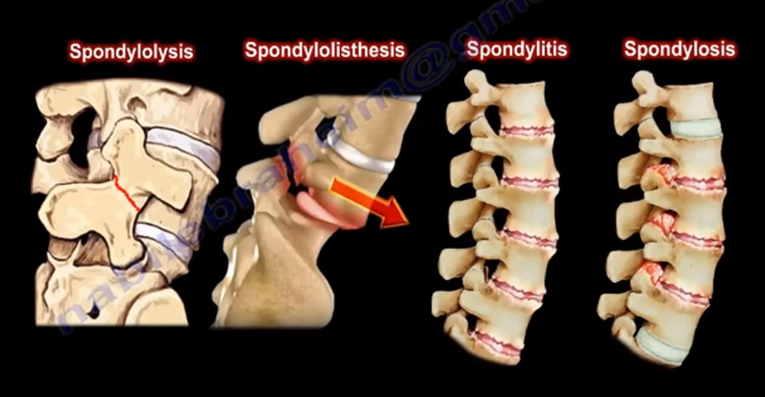

Via: https://www.huffpost.com/entry/conditions-with-confusing_b_11594592

On the radiologist’s report for Martha’s spine imaging, it states she has spondylosis. Conveniently, this is the only detail there as the rest of the report is missing.

Describe some of the features that may have been seen on imaging.
- Osteophytes (bony outgrowths)
- Narrowed intervertebral disc spaces (between vertebral bodies)
- Narrowing of intervertebral foramina
- Narrowing of spinal canal
- Disc herniation
- Thickened ligaments

Please provide feedback for this case at: https://forms.gle/R64a83Cf7UgRYc168

