Please note – this learning resource has been produced by the GUMS Academic Team. It is possible that there are some minor errors in the questions/answers, and other possible answers that are not included below. Make sure to check with other resources.

**Case 1 - congestive heart failure - AKI**

John Heartly is a regular patient of your clinic. He has had congestive cardiac failure for the last 10 years and this was caused by long standing cardiac hypertrophy due to aortic stenosis.

1. **Define ejection fraction and what is a normal range**

* Ejection fraction (EF) is a measurement, expressed as a percentage, of how much blood the left ventricle pumps out with each contraction.
* An ejection fraction of 60 percent means that 60 percent of the total amount of blood in the left ventricle is pushed out with each heartbeat.
* This indicates how well your heart is pumping out blood and can help to diagnose and track heart failure.
* A normal range is usually between 50 to 70%

1. **What do HFrEF and HFpEF mean and what is the pathophysiology of both?**

* **HFrEF** **= Heart failure with REDUCED ejection fraction** 
  + Also known as systolic HF
  + Most common
  + Reduced ejection fraction AND stroke volume
  + Underlying mechanisms:
    - **Reduced contractility:** Damage and loss of myocytes reduce ventricular contractility and stroke volume.
    - **Increased afterload:** increase in mean aortic pressure, outflow obstruction
    - **Increased preload:** ventricular volume overload
    - **Cardiac arrhythmias**
    - **High-output conditions** - secondary HF - conditions that lead to increased cardiac demand i.e. anemia, hyperthyroidism, pregnancy etc.
* **HFpEF = Heart failure with PRESERVED ejection fraction** 
  + Also known as diastolic HF
  + Reduced stroke volume but normal ejection fraction
  + Related to aging
  + Underlying mechanisms:
    - **Decreased ventricular compliance:** increased stiffness or impaired relaxation of the ventricle → reduced ventricular filling and increased diastolic pressure → decreased cardiac output
    - **Increased afterload;** increase in pulmonary artery pressure
    - **Increased preload;** ventricular volume overload

John has come to your clinic today complaining of urinary infrequency and even when he is able to go he produces a small volume of urine. You order some blood tests and the results show the following:

* Elevated creatinine (Cr)
* Elevated urea
* BUN:Cr > 20
* FENa < 1%
* Urine Osmolarity > 500

1. **Given his history of heart failure what is the most likely diagnosis? Briefly explain**

* Pre-renal Acute Renal Injury (AKI)
* Decreased blood supply to kidneys (due to hypovolemia - decreased circulating volume); → decreased GFR → activation of renin-angiotensin system → increased aldosterone release → increased reabsorption of Na+, H2O → increased urine osmolality → secretion of antidiuretic hormone → increased reabsorption of H2O and urea
* ***Also note FENa isn’t as important to know examwise but is good to know clinically
  + FENa = fractional excretion of sodium
  + percentage of the glomerular filtered sodium that is excreted in the urine.
  + Used to determine the cause of acute kidney injury. While a FENa < 1% is consistent with prerenal AKI, a FENa > 1% suggests intrinsic AKI.

1. **Why is a BUN:Cr ratio used in kidney disease and what is the normal range**

* The BUN/Creatinine ratio is useful in the differential diagnosis of acute or chronic renal disease. BUN/Creatinine ratio test results have been proven to be one of the best ways to diagnose acute or chronic renal disease, gastrointestinal bleeding, and urinary tract blockages.
* Reduced renal perfusion, e.g., congestive heart failure, or recent onset of urinary tract obstruction will result in an increase in BUN/Creatinine ratio.
* Increased urea formation also results in an increase in the ratio, e.g., gastrointestinal bleeding, trauma, etc.
* When there is decreased formation of urea as seen in liver disease, there is a decrease in the BUN/Creatinine ratio.
* In most cases of chronic renal disease the ratio remains relatively normal.
* Normal range is usually between 15:1 to 20:1

1. **Outline the pathophysiological mechanism for increased BUN:Cr ratio in patients with pre-renal AKI**

* Less blood flow to kidney → RAAS activates → more water reabsorption from aldosterone’s action → this is coupled with enhanced proximal tubular reabsorption of urea, which is disproportionate to creatinine reabsorption → elevated BUN:Cr

1. **Briefly explain how the following would also lead to pre-renal AKI: pulmonary embolism, tension pneumothorax, anaphylaxis**

* Prerenal causes include any condition leading to **decreased renal perfusion.**
* **Pulmonary embolism**
  + pulmonary blood vessels obstructed → less blood flow to left side of heart → less blood ejected to systemic circulation AND
  + PE causes right heart failure → further exacerbates lack of blood flow
* **Tension pneumothorax** -
  + kinking of veins returning into right atrium → same as above
* **Anaphylaxis** -
  + widespread oedema leads to increased volume in interstitium and hence decreased volume in plasma

John comes back a few weeks later still not well and the tests are redone which show the following

* BUN:Cr <15
* FENa > 2%
* Urine osmolarity < 500
* Muddy brown granular casts in urine

1. **What is most likely the new diagnosis given the results above and what has caused this?**

* John now has INTRA-renal AKI (also known as “intrinsic” AKI), in particular he has **acute tubular necrosis** - which is the most common cause of intra-renal AKI
* Prolonged prerenal failure leads to intra-renal failure because decreased renal perfusion causes tubular necrosis
* **key concept is intra-renal AKI is commonly preceded by pre-renal AKI
* The main causes of acute tubular necrosis are
  + **Ischemic:** Injury occurs secondary to decreased renal blood flow
  + **Toxic:** Injury occurs directly due to nephrotoxic substances
  + **Other:** sepsis, infection

1. **Explain the difference in John’s FENa and urine osmolality compared the his initial visit and why he now has casts in his urine**

* In pre-renal AKI, there is **no** damage to the renal tubules.
* In **acute tubular necrosis**,
  + necrosis or apoptosis of tubular cells → decreased reabsorption capacity of electrolytes (e.g., Na+), water, and/or urea; → increased Na+ and H2O in the urine → decreased urine osmolality and high FENa
  + Casts are from dead tubular epithelial cells sloughing into tubular lumen

It has been 4 months since you last saw John and you order blood tests which show his kidney function has continued to deteriorate and he now has chronic kidney disease (CKD).

1. **List the clinical features of Chronic kidney disease**

* A good mnemonic for Chronic Kidney disease is **“MAD HUNGER”** 
  + **M**etabolic **A**cidosis
  + **D**yslipidemia (especially high triglycerides)
  + **H**igh Potassium
  + **U**remia - clinical syndrome marked by
    - Nausea, anorexia
    - Pericarditis
    - Asterixis
    - Encephalopathy
    - Platelet dysfunction
  + **N**a+/H2O retention (HF, pulmonary oedmea, hypertension)
  + **G**rowth retardation and developmental delay
  + **E**rythropoietin failure (anemaia)
  + **R**enal osteodystrophy
* Less advanced stages usually asymptomatic
* Oliguria - Urine output < 400mL in 24 hour
* ↑ fluid volume → Peripheral oedema, pulmonary oedema
* Skin → Uremic pruritus, excoriations
* GI tract → Ulcerations, bleeding, diarrhea, vomiting
* Azotemia/uremia/Encephalopathy → Fatigue, somnolence, appetite loss, asterixis, confusion, seizures, paresthesias, uremic pericarditis
* Hyperkalemia → Cardiac arrhythmias
* Anemia → Low erythropoietin production by kidneys
  + ↑ Risk of infection
  + ↑ Bleeding tendency secondary to platelet dysfunction
* Chronic kidney disease-mineral and bone disorder (CKD-MBD): abnormalities of mineral or bone metabolism in the setting of chronic renal disease
* **Side note** a Mnemonic for Uremia is **“RESIN & 8P's”**
  + R- Retinopathy
  + E- Excoriations (scratch marks)
  + S- Skin is yellow
  + I- Increased blood pressure
  + N- Nails are brown
  + P- Pallor
  + P- Purpura and bruises
  + P- Pericarditis and cardiomegaly
  + P- Pleural effusions
  + P- Pulmonary oedema
  + P- Peripheral oedema
  + P- Proximal myopathy
  + P- Peripheral neuropathy

1. **Explain the mechanism of hyperparathyroidism in CKD?**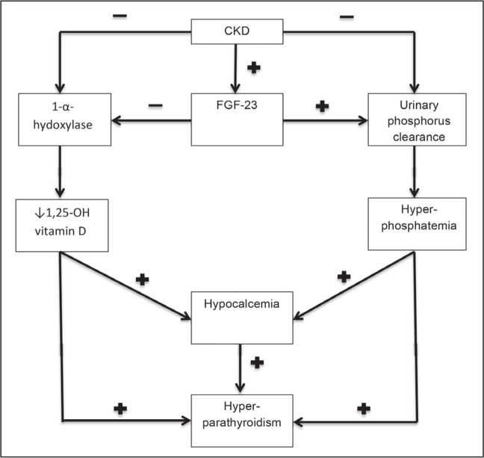

* It is secondary to derangements in the homeostasis of calcium, phosphate, and vitamin D
* Decreased hydroxylation of vit D → less intestinal Ca2+ absorption → decreased serum calcium → increased parathyroid hormone
* Also decreased excretion of phosphorus → increased serum phosphorus → decreased serum calcium → increased parathyroid hormone

**Case 2 -**

You are on the renal ward at GCUH. You have a few patients who have various kidney diseases each presenting with symptoms of the nephrotic syndrome.

1. **What are the components of the filtration barrier in the kidney?**

* FenestratedCapillary endothelium
* Glomerular Basement membrane (GBM)
* Foot processes of podocytes

1. **What are the differences in presentation and overall pathophysiology of nephrotic syndrome vs nephritic syndrome**

|  |  |  |
| --- | --- | --- |
|  | **Nephrotic Syndrome** | **Nephritic Syndrome** |
| **Presentation** | Heavy proteinuria (> 3.5 g/day)  Hypoalbuminemia  Generalized oedema  Hyperlipidemia and fatty casts in urine → frothy urine  Hypertension  ↑ Risk of thromboembolism: (via loss of antithrombin III)  ↑ Risk of infection | Proteinuria (< 3.5 g/day) (can be in nephrotic range in severe cases )  Hematuria with acanthocytes  RBC casts in urine  Mild to moderate oedema  Oliguria  Azotemia  Hypertension  Sterile pyuria |
| **Pathophysiology** | Damage to podocytes → structural damage of glomerular filtration barrier → massive renal loss of protein | Inflammatory response within glomeruli → GBM disruption → loss of renally excreted RBCs (acanthocytes) and ↓ GFR → hematuria, oliguria, azotemia, and ↑ renin → edema and hypertension  Damage to podocytes → structural damage of glomerular filtration barrier → massive renal loss of protein |

1. **Explain the mechanism leading to each of the following symptoms of the nephrotic syndrome.**

* **Proteinuria**
* **Peripheral oedema**
* **Hyperlipidemia and fatty casts in urine**
* **Decreased prothrombin time**
* **Increased risk of infection**
* **Proteinuria** 
  + Derangement of the kidney filtration barrier leading to increased permeability.
  + This can be due to immune mechanisms or non immune mechanisms.
  + This leads to loss of protein and lipids into filtrate
* **Peripheral oedema** 
  + Loss of albumin/protein from blood = ↓ plasma oncotic pressure = fluid movement to interstitial fluid
* **Hyperlipidemia and fatty casts in urine** 
  + In response to low protein, the liver upregulates all protein and lipid production leading to hyperlipidaemia.
  + Fatty casts are due to loss of these lipids via urine, due to damage to the filtration barrier.
* **Decreased prothrombin time** 
  + Loss of anticoagulant proteins (such as antithrombin III) in the urine
* **Increased risk of infection** 
  + Due to loss of IgG and tissue oedema which compromises the local blood supply and immune response

1. **Briefly fill out the below table in regards to the different causes of nephrotic syndrome**

**know the basics don't need to know all details listed - comprehensive answers provided to give a better understanding**

|  |  |  |  |
| --- | --- | --- | --- |
| **Disease** | **Epidemiology** | **Associations** | **Treatment** |
| Minimal change disease | Most common cause of nephrotic syndrome in children | Often idiopathic  Secondary causes (rare)   * Immune stimulus (e.g., infection, immunization) * Tumors (e.g., Hodgkin lymphoma) * Certain drugs (e.g., NSAIDs) | Responds well to prednisone  Good prognosis |
| Focal segmental glomerulosclerosis | Most common cause of nephrotic syndrome in adults, especially in African American and Hispanic populations | Can be idiopathic  Heroin use  HIV infection  Sickle cell disease  Massive obesity  Interferon treatment  Congenital malformations (e.g., Charcot-Marie-Tooth syndrome) | Prednisone (often shows poor response)  If necessary, PLUS other immunosuppressants (e.g., cyclosporine, tacrolimus)  RAAS inhibitors  Usually leads to end stage renal disease if left untreated |
| Membranous nephropathy | Most common cause of nephrotic syndrome in adults of European, Middle Eastern, or North African descent | **Primary:** anti-PLA2R antibodies  **Secondary:**  Infections (HBV, HCV, malaria, syphilis)  Autoimmune diseases (e.g., SLE)  Tumors (e.g., lung cancer, prostate cancer)  Medications (e.g., NSAIDs, penicillamine, gold) | RAAS inhibitors  Prednisone (often shows poor response)  PLUS other immunosuppressants (e.g., cyclophosphamide) in severe disease  Usually leads to end stage renal disease if left untreated |
| Diabetic nephropathy | Leading cause of end stage renal failure in high-income countries | Usually additional signs of other organ system complications (e.g., retinopathy, neuropathy) | Stringent glycemic control  RAAS inhibitors |
| Amyloid nephropathy | More commonly seen in elderly patients | The kidney is the most commonly affected organ in systemic amyloidosis.  Other organs might be involved simultaneously (e.g., the heart).  Multiple myeloma (AL amyloidosis)  Chronic inflammatory disease, e.g., tuberculosis, rheumatoid arthritis (AA amyloidosis) | Melphalan, corticosteroids  Treatment of underlying disease (e.g., bone marrow transplantation may be used for multiple myeloma) |

Table adapted from Amboss - nephrotic syndrome

1. **Some of these patients go on to develop various other complications. Explain the mechanism of the following signs and symptoms for THESE patients.**
2. **Unilateral calf pain and swelling**
3. **Dyspnoea, stony dull percussion note and decreased breath sounds at the base of the lungs bilaterally**
4. **Sudden onset flank pain with an acute decline in GFR**
5. **Unilateral calf pain and swelling**

* Patient has a DVT
* Increased clotting factor production and loss of antithrombin III = hypercoagulable state = predisposed to DVT.
* Patient is also in hospital (likely on bed rest) so there is likely a stasis of blood.
* Increased risk of endothelial damage due to hyperlipidaemia as a result of nephrotic syndrome.

1. **Dyspnoea, stony dull percussion note and decreased breath sounds at the base of the lungs bilaterally**

* Patient has pleural effusion, due to loss of protein from blood - Loss of albumin/protein from blood = ↓ plasma oncotic pressure = fluid movement to interstitial fluid
* Here, prompt discussion of exudate vs transudative pleural effusions – use this table as a guide: (table from amboss - pleural effusion)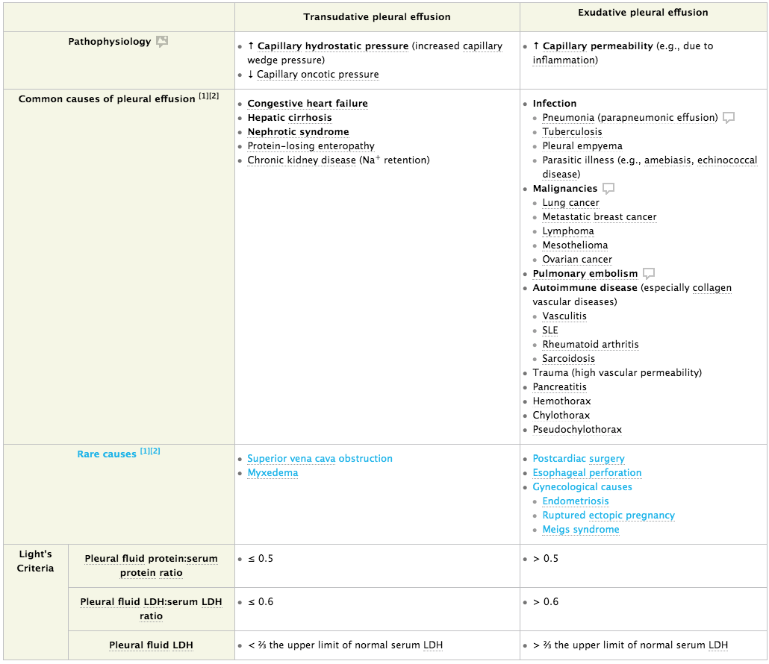

1. **Sudden onset flank pain with an acute decline in GFR**

* Renal vein thrombosis, caused by hypercoagulable state (as per DVT answer above)

**Stand alone questions...**

1. **What if another patient (not necessarily with nephrotic syndrome) presented with the following findings on urine dipstick analysis? Indicate whether they are normal found in urine or not, and indicate a possible cause (other than filtration barrier problems or medications)?**

* **Bilirubin** - No - Post-hepatic causes of jaundice (eg, bile duct obstruction)
* **Urobilinogen** - Yes - low concentrations of urobilinogen is normally excreted in urine
* **Glucose** - No - Diabetes mellitus
* **Haemoglobin** - No - Haemolysis, cancer, pyelonephritis

1. **Another patient presents with suprapubic pain, dysuria, urinary urgency and frequency. Their urine dipstick is positive for nitrites and leukocytes. Explain why.**

* Cystitis - UTI involving bladder and urethra
* Likely caused by E. coli, because E. coli has an enzyme that converts nitrates to nitrites
  + If no nitrites present, UTI likely due to non-E coli bacteria.
* Leukocytes present due to infection

**Please provide feedback for this case at:** [**https://docs.google.com/forms/d/1KmfO3yIEpnCBxAX8Q4alZIqdYBDVZaltx98rPMi63cs/edit**](https://docs.google.com/forms/d/1KmfO3yIEpnCBxAX8Q4alZIqdYBDVZaltx98rPMi63cs/edit)