Please note – this learning resource has been produced by the GUMS Academic Team. There may be some minor errors in the questions/answers, and other possible answers that are not included below. Make sure to check with other resources.

- In which of the following scenarios would you expect to see the highest renin activity?
- In a 70yo patient with essential hypertension
- In the affected kidney of a patient with renal artery stenosis
- In the unaffected kidney of a patient with renal artery stenosis
- In a patient taking an ACE inhibitor

- B-type natriuretic peptide is a hormone that is made in the ventricles of the heart. The influence of this hormone is to:
- Enhance atrial contractions
- Activate the renin-angiotensin system
- To prevent pH changes caused by organic acid
- To reduce blood pressure and blood volume by inhibiting sodium and water retention

- Administration of which of the following fluids is likely to increase a patient’s intravascular volume the most?
(NB: this question is probably a bit beyond ISM so don’t stress if you don’t get it. You DO NOT require the osmolarities to answer this question, think rather of the pressures keeping fluid inside blood vessels)
- 2L of 0.9% NaCl (normal saline)
- 1.5L of 5% dextrose
- 1L of 4% albumin
- 1L of 5% dextrose.
- 1L of 5% dextrose in 0.9% NaCl

- In which of the following patients would you expect to see the lowest serum concentration of Na+?
- A patient with diabetic insipidus
- A patient with syndrome of inappropriate ADH secretion (SIADH)
- A patient who’s just received 1 litre 0.9% NaCl of fluid resuscitation for dehydration
- A patient with primary hyperaldosteronism (Conn’s syndrome)

Miss Anderson presents to the emergency department supported by a bystander. She is severely confused and dehydrated after collapsing at a school athletic event. It is a hot day, and Miss Anderson has been in the sun with very little water intake.
You are asked by the consultant to rehydrate and actively cool Miss Anderson.
- After performing general observations and bloods and U&E you find Miss Anderson has:
Body weight | 62kg
Height | 165cm
Temperature | 37.2 (normal 36.8-37.5)
Heart Rate | 112 beats per minute (normal 60-100)
Blood Pressure | 115/70 mmHg lying down, but is 95/55 when standing (normal 100/60 – 140/90, with no difference between lying and standing)

FBC (full blood count) | Result (Reference Range Female Adult)
Haemoglobin (Hb) | 174g/L (115-165 g/L)
White Cell Count (WCC) | 10.5 x 10⁹ cells/L (4-11 x10⁹ cells/L)
Platelets | 250 x 10⁹ cells/L (150-400 x10⁹ cells/L)

Urea and Electrolytes | Result (Reference Range)
Sodium (Na) | 141 mmol/L (135-145 mmol/L)
Chloride (Cl-) | 109 mmol/L (95-110 mmol/L)
Urea | 19 mmol/L (3.0-8.0 mmol/L)
Creatinine | 111 μmol/L (45-90 μmol/L)
Osmolality | 313 mmol/kg (275-295 mmol/kg)

- Describe through physiological mechanisms, why Miss Anderson has a drop in blood pressure from lying to standing?

- Why are her urea and creatinine elevated?

- Why is her haemoglobin elevated?

- Match the infusion given intravenously to the corresponding body fluid shift. Assume that the osmolarity in both ICF and ECF is normal to start. Justify your answer.

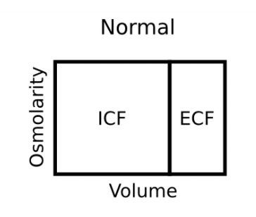
Starting with:

Isotonic Saline Infusion | 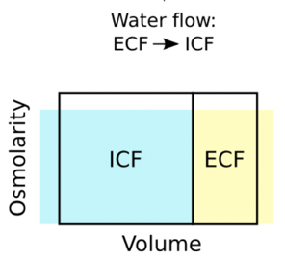  A
Hypertonic Saline Infusion | 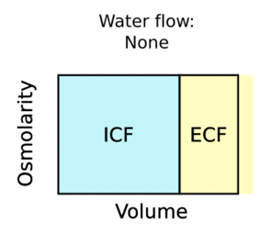  B
Glucose Infusion | 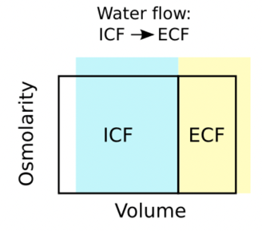  C

- The Consultant uses Miss Anderson’s case to test your understanding. They ask you to:

a) Discuss THREE key homeostatic/physiological mechanisms that are triggered by dehydration.

b) Describe the likely changes in MAP and cardiac output of this patient and how the homeostatic mechanisms previously discussed attempt to correct this.

c) Would the patient’s blood osmolarity likely be hypertonic, hypotonic or isotonic? What about their intracellular osmolarity?

You have successfully cooled and hydrated Miss Anderson, who is released from the hospital and advised to stay cool indoors with plenty of fluids.

Please provide feedback for this case at: https://forms.office.com/r/5rANEjhyrQ

