Please note – this learning resource has been produced by the GUMS Academic Team. There may be some minor errors in the questions/answers, and other possible answers that are not included below. Make sure to check with other resources.

SCENARIO 1

Max, a 16-year-old with a severe allergy to peanuts is dared by a friend to administer his Epipen (IM adrenaline) when he is not having an anaphylactic attack.

- Describe the various receptors adrenaline works on and contrast them to the cholinergic receptors. You may label the following diagram to help your understanding.
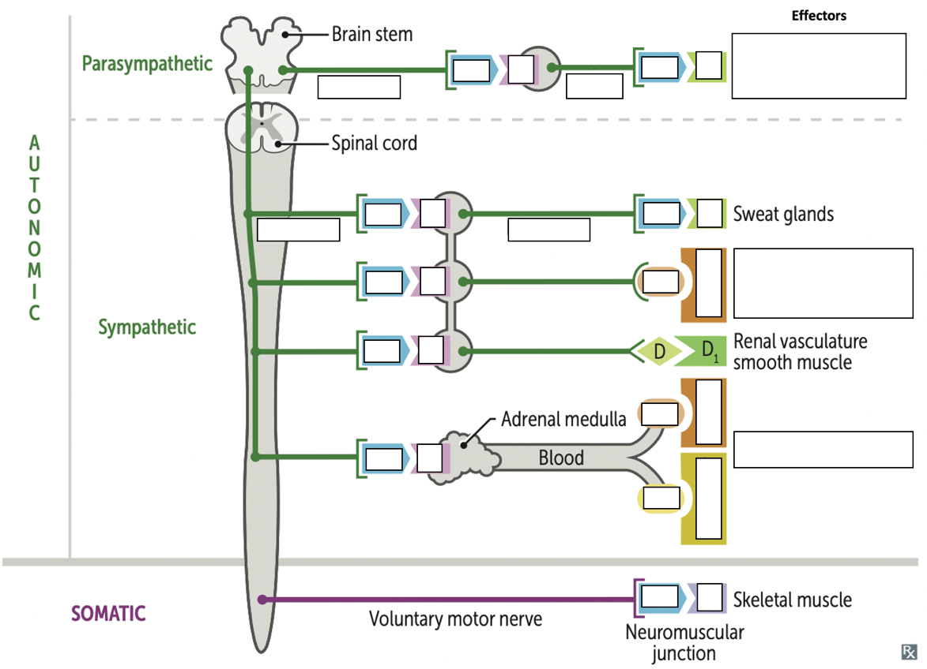

2. What major drugs mimic these receptors?

2. Max began to exhibit tell-tale sympathetic signs. Compare and contrast the SNS and PNS systemic effects.

3. Why is adrenaline routinely given by IM injection instead of orally or IV?

4. Explain the concept of bioavailability in regards to oral vs IM vs IV administration

5. Describe what agonists and competitive and non-competitive antagonists are

SCENARIO 2
Mr. Roy has familial hypercholesterolemia and has been taking simvastatin, a HMG-CoA reductase inhibitor (statin), to lower his risk of CVS disease for the last 6 years. Today Mr Roy presents to his GP with coughing, fever and chest pain. The GP suspects a chest infection and prescribes clarithromycin (a macrolide antibiotic). Simvastatin is broken down via CYP450 system and clarithromycin is an inhibitor of the CYP450 pathway.

1. What concerns would you have by using these two medications together?

2. Briefly explain clearance (high and low, hepatic and renal) and how this relates to this scenario.

3. Briefly explain the cytochrome P450 system

4. List 2 options for appropriate management of Mr Roy’s condition

Please provide feedback for this case at:
https://forms.office.com/r/5rANEjhyrQ

