Please note – this learning resource has been produced by the GUMS Academic Team. There may be some minor errors in the questions/answers, and other possible answers that are not included below. Make sure to check with other resources.

SCENARIO 1:
Max, a 16-year-old with a severe allergy to peanuts is dared by a friend to administer his Epipen (IM adrenaline) when he is not having an anaphylactic attack.

1. Describe the various receptors adrenaline works on and contrast them to the cholinergic receptors. You may label the following diagram to help your understanding.
- Adrenergic fibres secrete NA, cholinergic secrete Ach
Receptor types
Receptor  types | NA vs Adr | Most sympathetic target tissues | Ip3/DAG/Ca path | Excitatory
A1 | NA = Adr | Vascular smooth muscle | Ip3 and DAG increase Ca rises | Excitatory
A2 | NA > Adr | CNS, Digestive organs | Inhibits cAMP | Inhibitory
B1 | NA = Adr | Heart | Stimulates cAMP | Excitatory
B2 | Adr only | Smooth muscle – arterioles, bronchi | Stimulates cAMP | Inhibitory
Muscarinic | Ach from postgang | Cardiac & smooth muscle, glands | Various GPCRs | Depends on effector
Nicotinic | Ach from pregang & motor neurons | All postgang cell bodies, adrenal medulla, motor end plates | Open ligand-gated cation channels | Excitatory
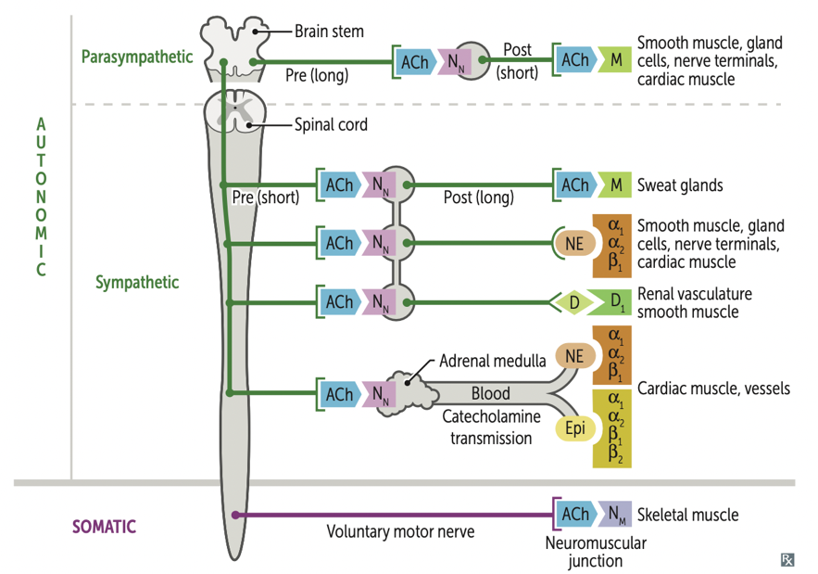

2. What major drugs mimic these receptors?
Drugs which mimic
- A1 agonist – phenylephrine – nasal decongestant, constricts nasal vessels
- A1 antagonist – prazosin - antihypertensive, causes vasodilation
- B1 antagonist – metoprolol – antihypertensive, decreases HR and contractility
- B2 agonist – salbutamol – dilates bronchioles, asthma reliever
- Muscarinic antagonist – atropine – used for bradycardia, organophosphate poisoning
- Muscarinic agonist – carbachol
- Anti-cholinesterase (organophosphates) – blocks acetylcholinesterase, leading to build up of Ach
- Cholinesterase re-activators – pralidoxime/2-PAM – reactive acetylcholinesterase by cleaving phosphate-ester bond

3. Max began to exhibit tell-tale sympathetic signs. Compare and contrast the SNS and PNS systemic effects.

Major effects:
Sympathetic | Parasympathetic
Dilated pupil | Constrict pupil
Inhibits salivation, other secretions | Increase salivation, mucus, tears
Relaxes airway smooth muscle | Constrict airway smooth muscle
Incr. HR & contractility, constricts blood vessels (except muscles, dilate due to adrenaline) | Slows heart and decreases HR
Inhibits digestion | Stimulates digestion
Stimulates glucose release in liver | Stimulates gallbladder
Secrete adrenaline/NA from adrenal gland | No innervations of liver, blood vessels, kidney
Relaxes bladder | Contracts bladder
Contracts rectum | Relaxes rectum
Ejaculation | Erection

+ DUMBELLS (diarrhoea, urination, miosis, bronchorrhoea, body fasciculations, emesis, lacrimation, lethargy, salivation) + SLUDGE (salivation, lacrimation, urination, defecation, gastric emptying, emesis)

4. Why is adrenaline routinely given by IM injection instead of orally or IV?
- Oral has high first past metabolism (explain first past metabolism as listed below)
- IV route has erratic and unpredictable distribution and very high risk as straight into blood system
- IM has a lower and more predictable distribution from the muscle than IV route
First Pass Metabolism
- When orally administrated drugs are partially or completely inactivated by the gut or liver before entering circulation
- Limits oral administration of highly metabolised drugs – higher doses needed
- Heroin and naloxone both undergo extensive first pass metabolism – therefore injected straight into bloodstream, rapidly crosses blood brain barrier

5. Explain the concept of bioavailability in regards to oral vs IM vs IV
Bioavailability = fraction of administered dose which makes it into the bloodstream
- Orally administered drugs – only a portion of the dose makes it to the bloodstream, depending on absorption and first pass clearance
- Absorption mainly affected by drug properties e.g. solubility and charge. Also by blood flow thru GIT, food consumed at same time etc
- First pass clearance is when the drug is metabolised, usually by CYP450 enzymes, after travelling to the liver via the portal vein.
- Bioavailability = F = Fg x Fh (amount absorbed x amount escaping liver extraction)
- Drugs administered intravenously have 100% bioavailability

6. Describe what agonists and competitive and non-competitive antagonists are
Antagonists and agonists work at receptor sites to either inhibit/Block or stimulate a response from said receptor. Competitive antagonists or agonists “compete” against a natural substrate for a binding site whereas a non-competitive agent binds at a different site to the endogenous substrate.

SCENARIO 2:
Mr. Roy has familial hypercholesterolemia and has been taking simvastatin, a HMG-CoA reductase inhibitor (statin), to lower his risk of CVS disease for the last 6 years. Today Mr Roy presents to his GP with coughing, fever and chest pain. The GP suspects a chest infection and prescribes clarithromycin (a macrolide antibiotic). Simvastatin is broken down via CYP450 system and clarithromycin is an inhibitor of the CYP450 pathway.

1. What concerns would you have by using these two medications together?

Clarithromycin will reduce the metabolism of simvastatin and may increase the risk of side effects and toxicity including rhabdomyolysis (explain if student don’t know what that is, which is the breakdown of muscle).

2. Explain (in brief terms) clearance (high and low, hepatic and renal) by the liver and how this relates to this scenario.
Clearance
- Volume of blood cleared of a drug per unit of time – mL/min, L/hr
- Total clearance includes renal, hepatic, and other
- Excretion ratio = how much of the drug is cleared in one pass – e.g. 0.66 would indicate two thirds of the drug is cleared through the liver
- High hepatic clearance / excretion ratio indicates only a small % of a drug reaches circulation
  - Prefer to give IV or sublingually, straight into bloodstream
- Low hepatic clearance / excretion ratio – most of drug reaches system circulation
- In the case above, clarithromycin is an inhibitor of CYP450, therefore there will reduce the hepatic clearance of simvastatin resulting in a higher proportion of the drug reaching systemic circulation.

3. Briefly explain the cytochrome P450 system
The Cytochrome P450 system is a group of enzymes which are responsible for breaking down exogenous molecules including medications and toxins. Different medications can either stimulate or inhibit this system leading to potentially unwanted effects including drug toxicity or treatment failure.
For example, clarithromycin inhibits the CYP450 breakdown of simvastatin leading to simvastatin accumulation and toxicity, whereas Phenytoin (an epilepsy drug) can induce the system to break itself and other antiepileptics down faster, leading to poor seizure control.

4. List 2 options for appropriate management of Mr Roy’s condition
- Prescribe an alternative antibiotic such as a Penicillin or
- Tell Mrs. Lipo to stop taking her simvastatin till she has finished the course of clarithromycin.

Please provide feedback for this case at: https://forms.office.com/r/5rANEjhyrQ

