Please note – this learning resource has been produced by the GUMS Academic Team. They may be some minor errors in the questions/answers, and other possible answers that are not included below. Make sure to check with other resources.

Label the Wigger Diagram and answer the following questions
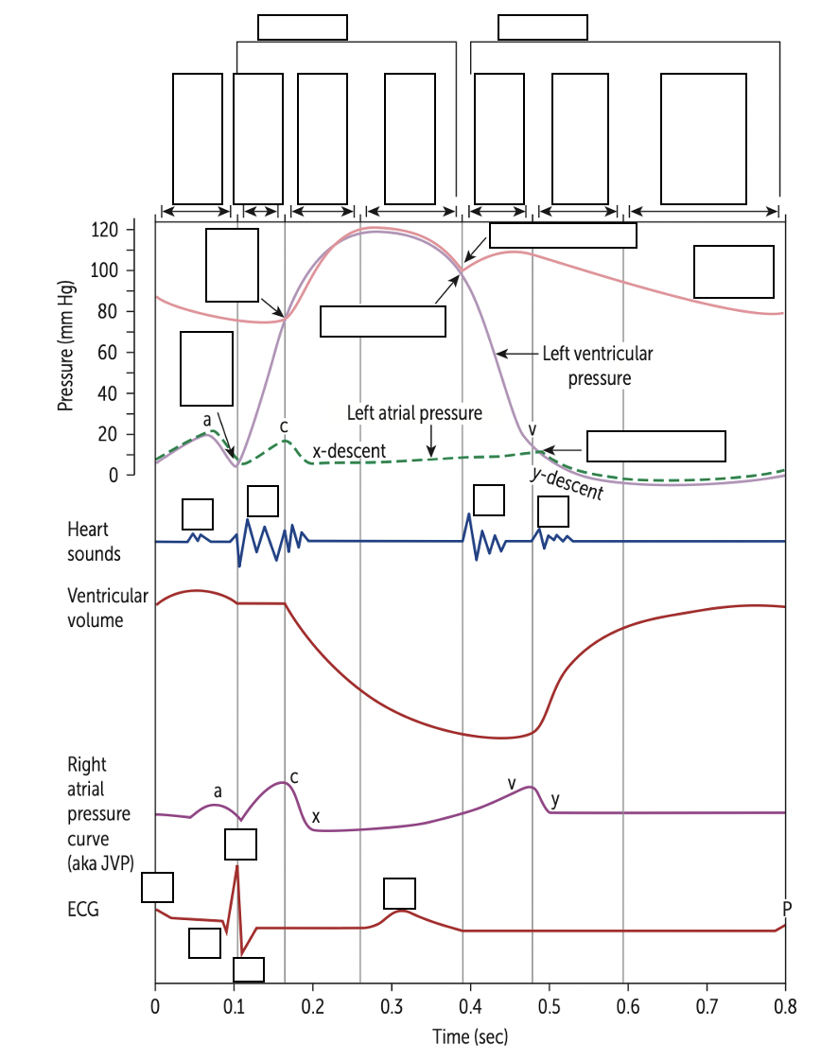Note*
Important students have a very GENERAL understanding of the above diagram -> what generally occurs when blood flows from atria to ventricles (i.e more blood = increased pressure) + general electrophysiology
ECG:
- What does the P wave represent?

- What does the T wave represent?

Lub dub sounds:
- S1 is heard due to

- S2 is heard due to

11) Explain the difference between essential and secondary hypertension with examples

12) Explain the difference between primary and secondary hyperlipidaemia with examples

PART 2

- What is the mechanism of action of nitrates (Nitroglycerin) in regards to the heart and coronary vessels?

- During a normal cardiac cycle: what is the state of heart valves during diastole?

Mr Sanders presents to the ED clutching his chest and complaining of chest pain.

Question 3:
Name 6 medical conditions that could cause My Sander’s chest pain (you may not have covered all 6):

Vascular (2):

Cardiac (2):

Respiratory (1):

GI (1):

Question 4:
What is the main clinical difference between Stable and Unstable Angina?

Mr Sanders has been overweight for most of his adult life, despite numerous attempts to lose weight. He began to smoke 5 years ago. He lives with his wife and 2 children. He has a history of hayfever but is otherwise generally well.

Question 5:
Name 2 Modifiable and 2 Non-Modifiable Risk Factors Mr Sanders has for his chest pain

Modifiable:

Non-Modifiable:

Question 6
Number the following in the correct order which describes the formation and development of an atherosclerotic plaque (1-10)

LDLs (low density lipids) become oxidised and release chemotactic agents.

Endothelial cells become activated and macrophages produce chemicals that activate smooth muscle cells and cause their proliferation and migration into the tunica intima blood vessels.

A fibrous cap forms, containing ECM (extracellular matrix) proteins such as collagen and fibrin

There is a loss of endothelial integrity and initiation of the inflammatory process

LDLs move from the lumen of the blood vessels into its tunica media

Macrophages engulf the oxidised LDLsm transforming into foam cells.

Monocytes are attracted to the area
The lipid core can become necrotic.

The fibrous cap hardens and has the potential to rupture, this triggers the formation of a thrombus.

Monocytes migrate between the tight junctions of the endothelial cells to reach the sub-endothelial space and differentiate into macrophages.

Please provide feedback for this case at:
https://forms.office.com/r/5rANEjhyrQ

