Please note – this learning resource has been produced by the GUMS Academic Team. They may be some minor errors in the questions/answers, and other possible answers that are not included below. Make sure to check with other resources.

Label the Wigger Diagram and answer the following questions
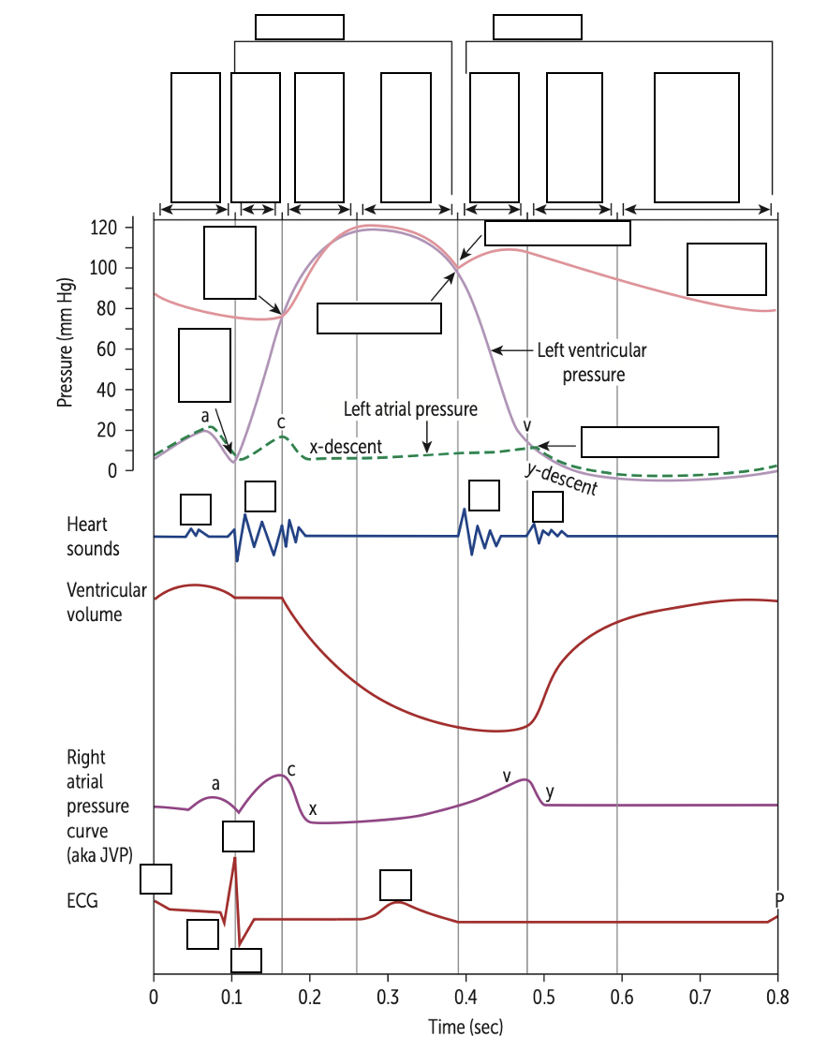

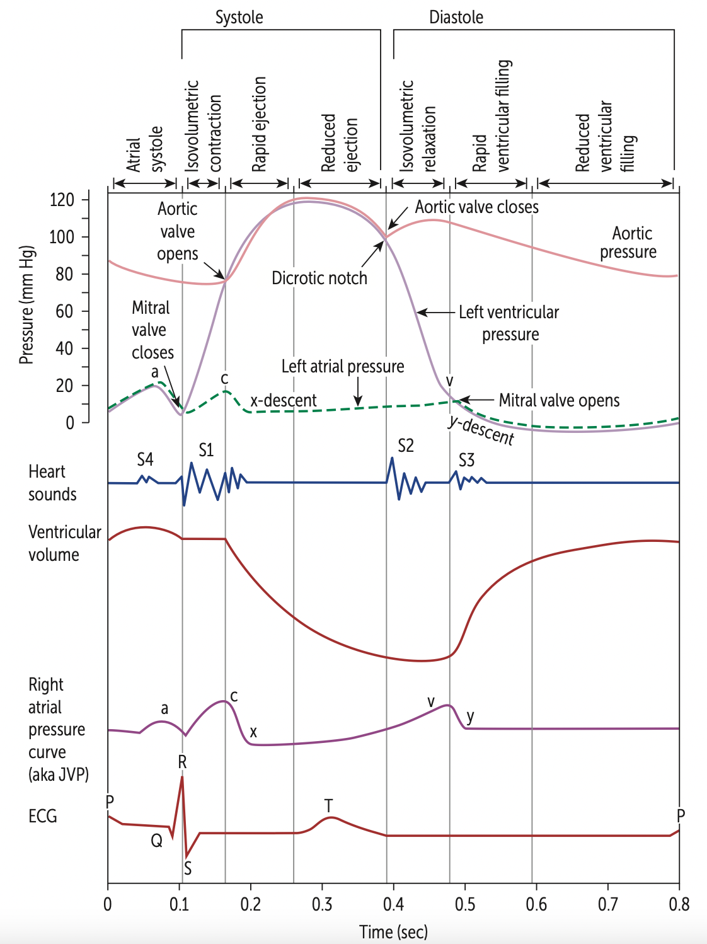
Source: USMLE 2021
JVP -> Important clinical sign often noted on physical examination of the patient (sign of fluid overload - do NOT need to know individual waves)
Important students have a very GENERAL understanding of the above diagram -> what generally occurs when blood flows from atria to ventricles (i.e more blood = increased pressure) + general electrophysiology

What does the P wave represent?
Atrial depolarisation

What does the T wave represent?
Ventricular Repolarisation

Lub dub:
S1 is heard due to
Beginning of Systole: so the ventricles are beginning to contract and rising pressure causes the mitral and tricuspid valves to close, the sound is turbulent blood flow caused by blood hitting the closed mitral and tricuspid valves.

S2 is heard due to
Beginning of diastole: the relaxation of the ventricles aortic and pulmonary valves closing, the sound is turbulent blood flow caused by blood hitting the closed aortic and pulmonary valves

Explain the difference between essential and secondary hypertension with examples.
Essential HTN (essential HTN): no exact identifiable cause of HTN, however thought to be associated with lifestyle factors (age, diabetes, smoking, obesity, environment, family history)
Secondary HTN: identifiable cause e.g., renal artery stenosis (↓blood flow to kidney = ↑ renin), Pheochromocytoma (adrenaline producing tumour), Aortic coarctation (↓blood flow to kidneys ↑ renin) etc.

Explain the difference between primary and secondary hyperlipidaemia with examples
Primary hyperlipidaemia: due to family history/ genetic disposition (therefore is non-modifiable and requires medications needed to address lipid profile.
Secondary hyperlipaemia: Due to secondary causes (eg. Diabetes, lifestyle, see secondary HTN)

PART 2 ANSWERS
Question 1: What is the mechanism of action of nitrates (Nitroglycerin) in regards to the heart and coronary vessels?

Nitrates cause relaxation of smooth muscle cells within the tunica media of blood vessels causing vasodilation, specific to the heart, they increase coronary blood flow.

A fun extra function is GTN has major vasodilatory effect on the venous system -> decreasing central venous pressure resulting in a decreased load on the heart! (Note will decrease venous return but not enough to reduce coronary perfusion).

Question 2: During a normal cardiac cycle: what is the state of heart valves during diastole?

During diastole, the heart's muscles are relaxed, and blood is entering its chambers. The AV (mitral and tricuspid) valves are open to allow blood flow from the atria into the ventricles. The semilunar (aortic and pulmonary) valves are closed to prevent backflow from the aorta and pulmonary trunk.

Mr Sanders presents to the ED clutching his chest and complaining of chest pain.

Question 3:
Name 6 medical conditions that could have cause Mr Sander’s chest pain (you may not have covered all 6):
Vascular (2): Aortic dissection, Pulmonary Embolism
Cardiac (2): Acute coronary syndrome (STEMI) = angina, Cardiac Tamponade
Respiratory (1): Pneumothorax, pleural effusion
GI (1): Heart burn (Gastro-reflux) Boerhaave's syndrome (oesophageal rupture)

Question 4:
What is the main clinical difference between Stable and Unstable Angina?
Stable Angina: Pain on exertion. Resolves with rest
Unstable Angina: Pain at rest

Mr Sanders has been overweight for most of his adult life, despite numerous attempts to lose weight. He began to smoke 5 years ago. He lives with his wife and 2 children. He has a history of hayfever but is otherwise generally well.

Question 5:
Name 2 Modifiable and 2 Non-Modifiable Risk Factors Mr Sanders has for Angina

Modifiable: Diet and Smoking
Non-Modifiable: Male and Age

Question 6
Place the following in the correct order of the formation and development of an atherosclerotic plaque (1-10)

LDLs (low density lipids) become oxidised and release chemotactic agents. | 3
Endothelial cells become activated and macrophages produce chemicals that activate smooth muscle cells and cause their proliferation and migration into the tunica intima blood vessels. | 7
A fibrous cap forms, containing ECM (extracellular matrix) proteins such as collagen and fibrin | 8
There is a loss of endothelial integrity and initiation of the inflammatory process | 1
LDLs move from the lumen of the blood vessels into its tunica media | 2
Macrophages engulf the oxidised LDLsm transforming into foam cells. | 6
Monocytes are attracted to the area | 4
The lipid core can become necrotic. | 10
The fibrous cap hardens and has the potential to rupture, this triggers the formation of a thrombus. | 9
Monocytes migrate between the tight junctions of the endothelial cells to reach the sub-endothelial space and differentiate into macrophages. | 5

Please provide feedback for this case at:
https://forms.office.com/r/5rANEjhyrQ

