Please note – this learning resource has been produced by the GUMS Academic Team. There may be some minor errors in the questions/answers, and other possible answers that are not included below. Make sure to check with other resources.

What are the likely morphological classification of anaemia seen in the following cases (e.g. Macrocytic, microcytic and normocytic) and discuss why:
- A 20-year-old woman complaining of fatigue, lethargy and occasional shortness of breath, has just found out she is pregnant, she eats a vegetarian diet and has suffered from heavy menstrual bleeding.

- A 6-year-old boy of Mediterranean descent with Beta- Thalassaemia as diagnosed by haemoglobin electrophoresis.

- A 30-year-old woman diagnosed with Crohn’s disease (an inflammatory bowel disease that affects transmural gastrointestinal tract and impairs absorption) that is particularly affecting her terminal ileum (hint (this is covered in systems): (Iron is absorbed in the duodenum) (folate in jejunum) (bile and B 12 in terminal ileum)

- A 50-year-old man brought in by ambulance to the ED with multiple abdominal stab wounds who is bleeding profusely.

- A 70-year-old woman who is currently receiving dialysis for failing kidneys

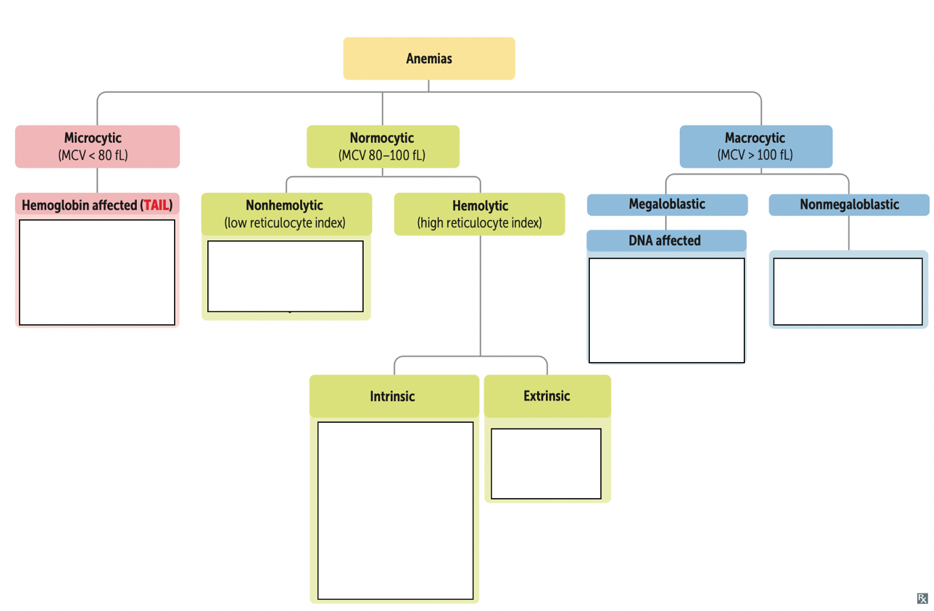
Name as many differential diagnoses as possible for the different classifications of anaemia below

Please provide feedback for this case at:
https://forms.office.com/r/5rANEjhyrQ

