Please note – this learning resource has been produced by the GUMS Academic Team. It is possible that there are some minor errors in the questions/answers, and other possible answers that are not included below. Make sure to check with other resources.

Case 1
You are a medical student at a GP clinic. The GP has asked you to take a history from Rachel Green a 24-year-old female presenting with fatigue.
Being an excellent historian, you take a thorough history. Rachel has been experiencing fatigue for ‘a number of’ months now. She sleeps 7-9 hours a day without interruption. Her ex-boyfriend, Ross, never complained that she snored. She works in the fashion industry. She hasn’t been under increased stress recently and reports her mood is “fine”. Her diet hasn’t changed much, but she has cut back on her meat intake as her friend and new housemate, Phoebe, is a vegetarian. She exercises by going for a run “a few times” a week but this has been getting harder with the fatigue. She thinks she may have gained some weight. She is a non-smoker, has never used drugs and drinks 2-3 wines on the weekend.
Her periods are 28-day cycles. She has 4-6 days of bleeding and uses heavy tampons throughout those days. She does not experience flooding but passes clots. Her LMP started 7 days ago. She hasn’t noticed any bleeding elsewhere. She has not been sexually active since Ross and her broke up.
She does not have any pre-existing medical conditions or had any surgeries. She does not take any medications or supplements. She does not have any allergies. She has no family history except that her mum has a “thyroid issue”. [Assume any other history/SR is negative.]

What are your two key differential diagnoses based on history and why?
Young female
- Iron deficiency anaemia – reduced dietary intake of red meat, heavy menstrual bleeding (?), exercise reduction
- Hypothyroidism – family hx, weight gain
Others if justified – e.g. EBV

(Questions to the group/food for thought: what might they expect to see on examination in relation to these differentials? How might they approach examining this patient (think: thyroid and cvs!)?)

What are some other differential diagnoses for fatigue and how might they be seen as less likely based on the history above? (Try and think of these in structured terms.)
Using “VINDICATE”
Vascular – cardiac causes (e.g. arrhythmia, heart failure, cardiomyopathy) unlikely due to patient age, negative family hx, nothing on hx to suggest (e.g. swelling, orthopnea)
Infection –
- HIV – no hx of IVDU, uncommon in Australia (low pretest probability), no known contacts or recent high risk sexual activity, no clinical features and fatigue has been for months, no comment on screening, technically possible but highly unlikely
- Hep C – no hx of IVDU or known contacts
- EBV – long hx of fatigue, nil other features such as lymphadenopathy, tonsillitis etc. on hx, possible (particularly given the age demographic)
Neoplasm – young female, nil constitutional sx, negative family hx, unlikely
Drugs/degenerative – not on any medications
Inflammatory/idiopathic
- Celiac – nil GI concerns, nil dietary changes, possible (in context of anaemia also) but less likely
Congenital
Autoimmune
Traumatic
- Psychological – negative mood screen, nil situational issues or changes
Endocrine/metabolic
- Diabetes – possible but no family hx, nothing in hx to suggest typical features (nocturia, polyuria, polydipsia)
Other:
- OSA – uninterrupted sleep, nil complaints suggestive (refer to Epworth Sleepiness Scale)
- Pregnancy – not sexually active, LMP 7 days ago
Many more…

You handover to the GP who asks you what you would like to do.
What investigations would you like to order based on your key differentials?
FBC – looking for anaemia, may also look at WCC to exclude infectious cause
Iron studies (ferritin, iron, iron saturation, transferrin)
+/- CRP – Ferritin is an acute phase reactant so interpretation of iron studies may be limited in inflammatory states
TFTs (TSH, FT4) – looking at thyroid function

Others to consider depending on your ddx:
- B12, folate
- Viral serology
- CHEM20 (urea and electrolytes, liver function tests, BSL) – simple and easy way to look for other causes, often done routinely anyway
- Thyroid antibodies (down the line)

One week later, Rachel returns for follow up of her test results. Her results are the following:
 | Result | Reference Range
Hb (g/L) | 147 | 115-160 (females)
WCC (x 10⁹/L) | 9.2 | 4.0-11.0
Plt (x 10⁹/L) | 268 | 140-400
Haematocrit | 0.43 | 0.33-0.47
MCH (pg) | 29.6 | 27.5-33.0
Red cell count (x 10¹²/L) | 4.97 | 3.80-5.20
MCV (fl) | 86 | 80-100
Neutrophils (x 10⁹/L) | 6.53 | 2.00-8.00
Lymphocytes (x 10⁹/L) | 1.86 | 1.00-4.00
Monocytes (x 10⁹/L) | 0.69 | 0.10-1.00
Eosinophils (x 10⁹/L) | 0.08 | <0.60
Basophils (x 10⁹/L) | 0.03 | <0.20
Sample appearance | Clear
Sodium (mmol/L) | 140 | 135-145
Potassium (mmol/L) | 4.0 | 3.5-5
Chloride (mmol/L) | 106 | 95-105
Bicarbonate (mmol/L) | 25 | 22-28
Anion gap (mmol/L) | 8 | 4-13
Random glucose (mmol/l) | 5.0 | 3.0-7.8
Urea (mmol/L) | 5.3 | 2.1-7.1
Creatinine (umol/L) | 61 | 55-120
Urea/creat | 87 | 40-100
eGFR (mL/min/1.73m2) | >90 | >90
Urate (mmol/l) | 0.36 | 0.15-0.45
Total protein (g/l) | 78 | 60-80
Total albumin (g/l) | 43 | 35-50
Globulin (g/l) | 35 | 25-45
Bilirubin (total) (umol/l) | 14 | <20
Bilirubin (conjugated) (umol/l) | <4 | <4
ALP (unit/l) | 57 | 30-110
yGT (unit/l) | 23 | <38
ALT (unit/l) | 13 | <34
AST (unit/l) | 22 | <30
LDH (unit/L) | 195 | 120-250
Calcium (mmol/l) | 2.49 | 2.1-2.6
Calcium (corrected) (mmol/l) | 2.43 | 2.1-2.6
Phosphate (mmol/l) | 0.76 | 0.75-1.50
Magnesium (mmol/l) | 0.75 | 0.70-1.10
Osmolality (calculated) (mmol/l) | 296 | 275-295
TSH (mIU/L) | 11.2 | 0.4-4.0
Free thyroxine (FT4) (pmol/L) | 6 | 10-25
Thyroid peroxidase antibody (TPOAb)* | 110 | <35 IU/mL
Thyroglobulin antibody (TgAb)* | 80 | <35 IU/mL
Serum iron (ug/dL) | 90 | 50-180
Transferrin (mg/dL) | 300 | 200-360
Ferritin (ug/l) | 105 | 20-220
CRP (mg/l) | 0.4 | <5

Interpret the blood results, including pertinent negatives. What is the most likely diagnosis?
Primary hypothyroidism – high TSH, low T4
- Hashimoto’s thyroiditis = primary hypothyroidism picture + TPOAb +/- TgAb
  - Most common cause of hypothyroidism in the West
  - Thyroid antibody tests are not perfect and should be interpreted alongside the TFTs and clinical picture
  - Antibodies against TPO are seen in 90-100% of Hashimoto’s cases; antibodies against thyroglobulin are seen in 80-90%
Pertinent negatives:
- Normal/borderline Hb with normal iron studies – excluding IDA
- BSL normal – diabetes less likely
- LFTs, WCC normal – hep C less likely
- Other electrolytes normal – less likely metabolic disturbance contributing to fatigue
- WCC, CRP normal – infectious causes less likely

FOR REFERENCE: Interpreting TFTs https://www.nps.org.au/australian-prescriber/articles/thyroid-function-tests
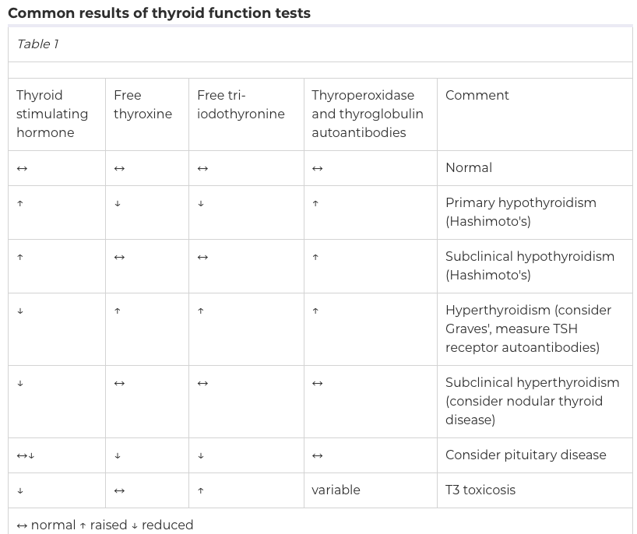

How would you like to manage this patient and follow up?
- Explain the results of the investigations
- Start her on levothyroxine (low dose and up titrate)
  - Important education points include: increased monitoring and demands in pregnancy, need for titration in early months, likely lifelong replacement, importance of compliance
- Monitor clinical symptoms and TFTs every 6-8 weeks initially and dose adjust for target TSH within normal range

What if….
1. Rachel was brought into the hospital with rapid onset nausea and vomiting, abdominal pain and altered GCS. She has a fruity odor on her breath. What would be your primary concern and what initial investigations would you order?
Diabetic ketoacidosis

Serum basic metabolic panel:
- Serum glucose – high glucose (although ~10% are euglycaemic!)
Urine dip – ketones +++ (from acetoacetate), glucosuria
VBG – high anion gap metabolic acidosis (low pH, low bicarb, elevated anion gap)
Serum β-hydroxybutyrate – high (more accurate than urine dip as urine does not detect β-hydroxybutyrate)

Investigations to identify cause, e.g. infection, pregnancy

IN PRACTICE: refer to the following guideline on your clinical placements next year https://www.health.qld.gov.au/__data/assets/pdf_file/0028/438391/diabetic-ketoacidosis.pdf - this is important in 3rd and 4th year
2. On follow up for her hypothyroidism, Rachel presents with difficulty sleeping, sweating, diarrhea and weight loss. On examination, her HR is 110. What could be happening?
These are features of hyperthyroidism – may be secondary to too much thyroxine (e.g. extra doses taken or not titrated appropriately)

3. Rachel had low TSH and low T3/T4. What would your differentials be (broadly speaking)?
This is suggestive of secondary or tertiary hypothyroidism (cannot tell from these 2 results alone)
- Secondary hypothyroidism – pituitary disorders, e.g. pituitary adenoma
- Tertiary hypothyroidism – hypothalamic disorder (🡪 TRH deficiency)

4. Rachel presented with a painless, hard thyroid lump. Ultrasound showed a solid hypoechoic nodule with irregular margins.
Suspicious for thyroid malignancy. She would likely require FNA cytology to exclude.

Red flags for thyroid malignancy: extremes of age, hard fixed nodule, history of radiation to head/neck, painless cervical lymphadenopathy, associated hoarseness/dysphagia/dyspnea, family hx, male, USS findings (solid hypoechoic nodule, irregular margins, microcalcifications), cold nodules on thyroid scintigraphy

Case 2
Rachel recalls how her friend Monica had difficulty sleeping and excessive weight loss and was started on a medication to manage her thyroid.
Name and compare the two antithyroid medications that Monica could be on. What might Monica’s doctor recommend when her and Chandler start trying for a baby?
Carbimazole and propylthiouracil are both antithyroid medications
MOA: They both block thyroid hormone synthesis. Propylthiouracil also inhibits peripheral conversion of T4 to T3.
- Carbimazole has a longer duration of action so can be given as once daily dosing (vs BD).
AEs: similar – itching, rash, gastro sx, headaches are common
- Important SEs: hepatotoxicity (especially PTU), agranulocytosis
PREGNANCY Carbimazole in the first trimester has been linked to congenital defects (although rare) so should be avoided in women planning to conceive or who are not using appropriate contraception. Propylthiouracil is generally preferred in trimester 1 (although also has a small increase in risk of birth defects during pregnancy). Levels should be checked every 6 weeks.
“Propylthiouracil = Preferred in Pregnancy (tri 1)”

What is the most common cause of hyperthyroidism in the west? What would you find on routine investigations for thyroid dysfunction?
Graves’ disease TFTs: low TSH, high T4 (consistent with primary hyperthyroidism),
Antibodies: TSHRAb (TSH receptor antibodies) (80-90%), +/- TPOAbs (~60%), +/- TgAbs (~60%)

Some random attempts at memory aids for when your brain fails mid exam:
“Graves attacks the Gates” – antibodies against the TSH receptors
hashimOtOs = hypothyroid gRavEs = hyperthyroid
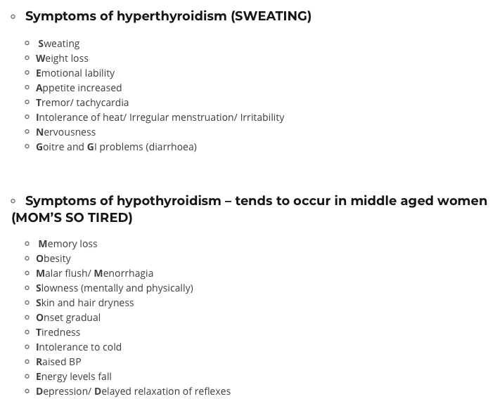
From: https://oxfordmedicaleducation.com/medical-mnemonics/endocrinology-mnemonics/

Monica eventually undergoes a partial thyroidectomy. She later presents to her GP complaining of fatigue and muscle cramps. On further questioning, she also reports feeling tingling around her mouth and in her fingers and toes. An ECG is done which reveals prolonged QT interval.

Which of the following serum abnormalities would you expect to see on her lab results?
A) Hyperkalaemia
B) Hypokalaemia
C) Hypercalcaemia
D) Hypocalcaemia
E) Hypermagnesaemia

Features of hypocalcemia – “CAN’T SIT”
- Chvostek’s sign
- Arrhythmias (prolonged QT)
- Numbness/tingling
- Trousseau’s sign
- Spasms
- Irritability
- Tetany
The key here is the history of the partial thyroidectomy (see below…)
Which hormone abnormalities could result in this patient’s electrolyte imbalance?
A) Hypoparathyroidism
B) Hyperthyroidism
C) Hypothyroidism
D) 17-hydroxyprogestrone deficiency
E) Hyperaldosteronism
What is the most likely cause of this hormone abnormality?
Surgical resection – this is the most common cause of hypoparathyroidism

Review the following statements regarding calcium homeostasis.
- A(n) increase/decrease in calcium leads to an increase in parathyroid hormone (PTH) secretion.
- PTH acts on the kidney to convert vitamin D to its active form: 1,25hydroxyvitamin D, which subsequently acts on the gut to increase absorption of calcium and phosphorus. It also works to increase/decrease phosphorus excretion and increase/decrease calcium reabsorption.

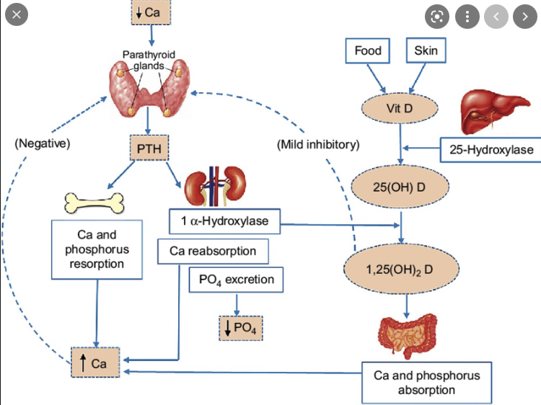

Case 3
Refer to the following investigation findings to answer the questions.

 | Joey | Chandler | Ross | Richard
Parathyroid hormone (PTH) | High | High | High | Very high
Calcium | Low | Low | High | High
Phosphorus | Normal/high | Low | Low | High

Based on the findings above, what is the most likely diagnosis from the options provided for Chandler?
- Chronic kidney disease
- Parathyroid gland adenoma
- Vitamin D deficiency
- Multiple endocrine neoplasia type 1
- Tertiary hyperparathyroidism
See below for explanation

Based on the findings above, what is the most likely diagnosis from the options provided for Joey?
- Chronic kidney disease
- Parathyroid gland adenoma
- Vitamin D deficiency
- Multiple endocrine neoplasia type 1
- Tertiary hyperparathyroidism
See below for explanation

Based on the findings above, what is the most likely diagnosis from the options provided for Ross?
- Chronic kidney disease
- Parathyroid gland adenoma
- Vitamin D deficiency
- Multiple endocrine neoplasia type 1
- Tertiary hyperparathyroidism

Explanation:
 | Joey | Chandler | Ross | Richard
PTH | High | High | High | Very high
Calcium | Low | Low | High | High
Phosphorus | Normal/high | Low | Low | High
Most Likely Diagnosis | Secondary (CKD) | Secondary (vitamin D deficiency) | Primary | Tertiary
All have raised PTH = hyperparathyroidism
- ROSS: A high PTH despite a high calcium suggests an intrinsic issue of the parathyroid causing unregulated release of PTH 🡪 primary hyperparathyroidism.
  - Parathyroid adenomas are the most common cause (~80%) of primary hyperparathyroidism
  - MEN type 1 is also a cause, but this is less likely and hence in the absence of additional clinical information (b) would be the MOST correct answer
- CHANDLER AND JOEY: Both have a high PTH and low calcium, suggestive of secondary hyperparathyroidism.
  - Normally a low calcium would lead to a high PTH 🡪 🡪 increased calcium.
  - JOEY: In chronic kidney disease there is:
    - Impaired excretion of phosphorus by kidney 🡪 increased serum phosphorus = stimulus for PTH excretion 🡪 increased PTH with normal/high phosphorus level
    - Less activation of vitamin D in kidney 🡪 decreased resorption of calcium (gut and renal) 🡪 increased PTH with low calcium
    - This is the most common cause of secondary hyperparathyroidism
    - Obviously you would also look at the kidney function to differentiate
  - CHANDLER: In vitamin D deficiency
    - Less vitamin D available for activation 🡪 decreased resorption of calcium (gut and renal) and phosphate (gut) 🡪 increased PTH with low calcium
    - PTH leads to decreased phosphorus reabsorption in kidney 🡪 low phosphorus

How would you explain the findings for Richard?
Richard shows features of tertiary hyperparathyroidism

This is most commonly due to parathyroid hyperplasia in the context of untreated secondary hyperparathyroidism leading to persistence of PTH release despite removal of stimulus (i.e. low calcium). Therefore, you get autonomous production of PTH 🡪 high calcium and phosphorus due to increased reabsorption. This is most commonly due to chronic kidney disease.

Feedback – please provide feedback on this PeerBL case here https://forms.office.com/r/9tYrrG0kKf

