Please note – this learning resource has been produced by the GUMS Academic Team. It is possible that there are some minor errors in the questions/answers, and other possible answers that are not included below. Make sure to check with other resources.

Case 1
You are a medical student at a GP clinic. The GP has asked you to take a history from Rachel Green a 24-year-old female presenting with fatigue.
Being an excellent historian, you take a thorough history. Rachel has been experiencing fatigue for ‘a number of’ months now. She sleeps 7-9 hours a day without interruption. Her ex-boyfriend, Ross, never complained that she snored. She works in the fashion industry. She hasn’t been under increased stress recently and reports her mood is “fine”. Her diet hasn’t changed much, but she has cut back on her meat intake as her friend and new housemate, Phoebe, is a vegetarian. She exercises by going for a run “a few times” a week but this has been getting harder with the fatigue. She thinks she may have gained some weight. She is a non-smoker, has never used drugs and drinks 2-3 wines on the weekend.
Her periods are 28-day cycles. She has 4-6 days of bleeding and uses heavy tampons throughout those days. She does not experience flooding but passes clots. Her LMP started 7 days ago. She hasn’t noticed any bleeding elsewhere. She has not been sexually active since Ross and her broke up.
She does not have any pre-existing medical conditions or had any surgeries. She does not take any medications or supplements. She does not have any allergies. She has no family history except that her mum has a “thyroid issue”. [Assume any other history/SR is negative.]

What are your two key differential diagnoses based on history and why?

What are some other differential diagnoses for fatigue and how might they be seen as less likely based on the history above? (Try and think of these in structured terms.)

You handover to the GP who asks you what you would like to do.
What investigations would you like to order based on your key differentials?

One week later, Rachel returns for follow up of her test results. Her results are the following:
 | Result | Reference Range
Hb (g/L) | 147 | 115-160 (females)
WCC (x 10⁹/L) | 9.2 | 4.0-11.0
Plt (x 10⁹/L) | 268 | 140-400
Haematocrit | 0.43 | 0.33-0.47
MCH (pg) | 29.6 | 27.5-33.0
Red cell count (x 10¹²/L) | 4.97 | 3.80-5.20
MCV (fl) | 86 | 80-100
Neutrophils (x 10⁹/L) | 6.53 | 2.00-8.00
Lymphocytes (x 10⁹/L) | 1.86 | 1.00-4.00
Monocytes (x 10⁹/L) | 0.69 | 0.10-1.00
Eosinophils (x 10⁹/L) | 0.08 | <0.60
Basophils (x 10⁹/L) | 0.03 | <0.20
Sample appearance | Clear
Sodium (mmol/L) | 140 | 135-145
Potassium (mmol/L) | 4.0 | 3.5-5
Chloride (mmol/L) | 106 | 95-105
Bicarbonate (mmol/L) | 25 | 22-28
Anion gap (mmol/L) | 8 | 4-13
Random glucose (mmol/l) | 5.0 | 3.0-7.8
Urea (mmol/L) | 5.3 | 2.1-7.1
Creatinine (umol/L) | 61 | 55-120
Urea/creat | 87 | 40-100
eGFR (mL/min/1.73m2) | >90 | >90
Urate (mmol/l) | 0.36 | 0.15-0.45
Total protein (g/l) | 78 | 60-80
Total albumin (g/l) | 43 | 35-50
Globulin (g/l) | 35 | 25-45
Bilirubin (total) (umol/l) | 14 | <20
Bilirubin (conjugated) (umol/l) | <4 | <4
ALP (unit/l) | 57 | 30-110
yGT (unit/l) | 23 | <38
ALT (unit/l) | 13 | <34
AST (unit/l) | 22 | <30
LDH (unit/L) | 195 | 120-250
Calcium (mmol/l) | 2.49 | 2.1-2.6
Calcium (corrected) (mmol/l) | 2.43 | 2.1-2.6
Phosphate (mmol/l) | 0.76 | 0.75-1.50
Magnesium (mmol/l) | 0.75 | 0.70-1.10
Osmolality (calculated) (mmol/l) | 296 | 275-295
TSH (mIU/L) | 11.2 | 0.4-4.0
Free thyroxine (FT4) (pmol/L) | 6 | 10-25
Thyroid peroxidase antibody (TPOAb)* | 110 | <35 IU/mL
Thyroglobulin antibody (TgAb)* | 80 | <35 IU/mL
Serum iron (ug/dL) | 90 | 50-180
Transferrin (mg/dL) | 300 | 200-360
Ferritin (ug/l) | 105 | 20-220
CRP (mg/l) | 0.4 | <5

Interpret the blood results, including pertinent negatives. What is the most likely diagnosis?

How would you like to manage this patient and follow up?

What if….
1. Rachel was brought into the hospital with rapid onset nausea and vomiting, abdominal pain and altered GCS. She has a fruity odor on her breath. What would be your primary concern and what initial investigations would you order?

2. On follow up for her hypothyroidism, Rachel presents with difficulty sleeping, sweating, diarrhea and weight loss. On examination, her HR is 110. What could be happening?

3. Rachel had low TSH and low T3/T4. What would your differentials be (broadly speaking)?

4. Rachel presented with a painless, hard thyroid lump. Ultrasound showed a solid hypoechoic nodule with irregular margins.

Case 2
Rachel recalls how her friend Monica had difficulty sleeping and excessive weight loss and was started on a medication to manage her thyroid.
Name and compare the two antithyroid medications that Monica could be on. What might Monica’s doctor recommend when her and Chandler start trying for a baby?

What is the most common cause of hyperthyroidism in the west? What would you find on routine investigations for thyroid dysfunction?

Monica eventually undergoes a partial thyroidectomy. She later presents to her GP complaining of fatigue and muscle cramps. On further questioning, she also reports feeling tingling around her mouth and in her fingers and toes. An ECG is done which reveals prolonged QT interval.

Which of the following serum abnormalities would you expect to see on her lab results?
A) Hyperkalaemia
B) Hypokalaemia
C) Hypercalcaemia
D) Hypocalcaemia
E) Hypermagnesaemia
Which hormone abnormalities could result in this patient’s electrolyte imbalance?
A) Hypoparathyroidism
B) Hyperthyroidism
C) Hypothyroidism
D) 17-hydroxyprogestrone deficiency
E) Hyperaldosteronism
What is the most likely cause of this hormone abnormality?

Review the following statements regarding calcium homeostasis.
- A(n) increase/decrease in calcium leads to an increase in parathyroid hormone (PTH) secretion.
- PTH acts on the kidney to convert vitamin D to its active form _______________, which subsequently acts on the _____ to increase absorption of calcium and phosphorus. It also works to increase/decrease phosphorus excretion and increase/decrease calcium reabsorption.

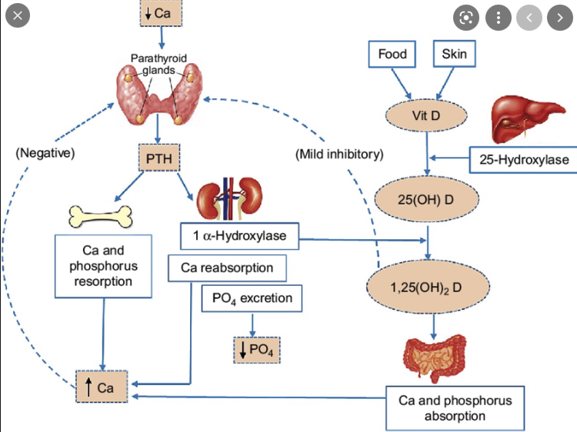

Case 3
Refer to the following investigation findings to answer the questions.

 | Joey | Chandler | Ross | Richard
Parathyroid hormone (PTH) | High | High | High | Very high
Calcium | Low | Low | High | High
Phosphorus | Normal/high | Low | Low | High

Based on the findings above, what is the most likely diagnosis from the options provided for Chandler?
- Chronic kidney disease
- Parathyroid gland adenoma
- Vitamin D deficiency
- Multiple endocrine neoplasia type 1
- Tertiary hyperparathyroidism

Based on the findings above, what is the most likely diagnosis from the options provided for Joey?
- Chronic kidney disease
- Parathyroid gland adenoma
- Vitamin D deficiency
- Multiple endocrine neoplasia type 1
- Tertiary hyperparathyroidism

Based on the findings above, what is the most likely diagnosis from the options provided for Ross?
- Chronic kidney disease
- Parathyroid gland adenoma
- Vitamin D deficiency
- Multiple endocrine neoplasia type 1
- Tertiary hyperparathyroidism

How would you explain the findings for Richard?

Feedback – please provide feedback on this PeerBL case here https://forms.office.com/r/9tYrrG0kKf

