CVS 1: Please note – this learning resource has been produced by the GUMS Academic Team. It is possible that there are some minor errors in the questions/answers, and other possible answers that are not included below. Make sure to check with other resources.
Case 1
38 year old Chloe presents to the GP with her 3 month old baby boy, John, after noticing he is turning blue more frequently. The first few incidents were when John was crying but recently he has also turned blue whilst feeding. Chloe also mentions when she took him to his previous check up he was underweight and was below average height for his age. As the GP, you listen to John’s heart and notice a murmur.
1. List the possible causes of John’s symptoms
2. What further tests would you order?

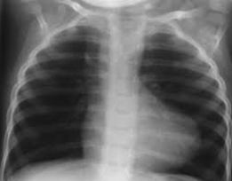
You refer John to a pediatric cardiologist who orders the above tests. The ECG shows right ventricular hypertrophy and on the chest X Ray the heart is “boot” shaped. There is an ejection systolic murmur in the pulmonary area and no signs of systemic congestion
3. What is the most likely diagnosis considering the new information and what other signs would you see

4. What is Tetralogy of Fallot and what are the 4 main features
5. What are Tet spells in Tetralogy of Fallot
6. Which of the following cause a left to right shunt
● Aortic stenosis
● Atrial septal defect (ASD)
● Tricuspid Atresia
● Ventricular septal defect (VSD)
● Patent Ductus Arteriosus
● Coarctation of aorta
● Tetralogy of Fallot

Case 2
56 year old, Harley Stevens presents to the emergency department complaining of severe chest pain at rest and it radiates down his left arm
7. What immediate differential do you have? Name two other signs or symptoms you would ask/look for?

8. What are the tests you would do to confirm your diagnosis

A ECG is performed on Harley and it shows ST depression and T wave inversion.
9. Based on the ECG findings name two differentials that can cause this and what is common to both of these differentials in terms of involvement of the myocardium

10. Complete the table below comparing the types of Acute Coronary Syndrome (ACS)
 | Unstable Angina (UA) | NSTEMI | STEMI
Description
Clinical
presentation
Pathophysiology
Cardiac
biomarkers
ECG findings

11. What type of patients are likely to present with Atypical signs of MI

12. Explain the rationale for giving nitrates in these conditions

13. What is an important consideration in the use is nitrates
Harley was also found to have elevated troponins (NSTEMI) and the doctors on rotation were from UQ and did not commence treatment straight after doing the initial ECG. A repeat ECG is taken and Harley is found to have ST elevation now
14. Describe what happened here?
The ECG shows ST elevation in leads V5, V6, I, aVL, II, III and aVF. He also developed a systolic murmur best heard at the 5th intercostal space, left midclavicular line.

15. Account for the ECG changes by stating an infarction site in a single location

16. Why has Harley developed a murmur

Harley then goes on to develop the following ECG. (12 lead ECG (paper speed: 25mm/s) 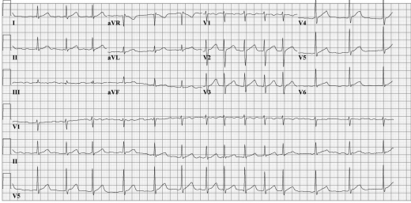
ECG from Amboss - Acute coronary syndrome
17. State the diagnosis and explain two mechanisms which could have caused this to arise
18. Following the MI and AF, what is the most important cardiac condition to monitor Harley for and how can it arise?

19. Account for the following x-ray following the infarction. What is the diagnosis and state the key clinical signs and symptoms you would expect.
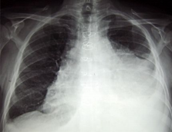

TO BE CONTINUED – CVS 2 (CASE 3)
Please provide feedback for this case at:
Microsoft Forms

References
● Amboss
● Dissa Lectures
● UpToDate
●https://www.ncbi.nlm.nih.gov/pmc/articles/PMC5442408/#:~:text=PATHOPHYSIOLOGY%20OF%20 HF%20AFTER%20MI,-Several%20overlapping%20mechanisms&text=HF%20during%20the%20ind ex%20MI,due%20to%20papillary%20muscle%20dysfunction.
● https://www.aihw.gov.au/reports/indigenous-australians/acute-rheumatic-fever-rheumatic-heart-disea se/contents/summary
● https://www.rhdaustralia.org.au/burden-disease
● https://www.ncbi.nlm.nih.gov/books/NBK2208/
● https://academic.oup.com/cid/article/30/2/374/381830

